**Preventive maintenance and inspection of air compressor**

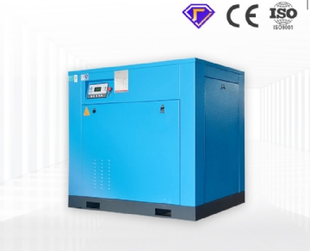

#### **Check the oil level of the compressor pump**

Unless your air compressor is an oil-free compressor， do not operate without lubricant or insufficient lubricant. The manufacturer and the company you purchased are not responsible for the failure of insufficient lubrication.

1. Make sure the device is turned off and powered off
2. Make sure the compressor is on a flat and level surface
3. Remove the filler cap / plug
4. Check the oil in the crankcase assembly and look for dirt or debris
5. The amount of oil must not exceed the midpoint of the mirror

#### **Replace the compressor pump oil**

Remember， the compressor head and surrounding parts are very hot!

1. Make sure the device is turned off and powered off
2. Make sure the compressor is on a flat and level surface
3. Remove the filler cap / plug
4. Place the collecting container under the oil drain cap.
5. Remove the oil drain cap and allow the oil to flow out.
6. Replace the oil cap and ensure that the nut is tightened securely. White plumber tape (PTFE) is usually a good idea to help create a tighter seal. Fill the crankcase with suitable oil to ensure that it does not exceed the midpoint.

#### **Check the air filter element**

It is a more common reciprocating air compressor.

1. Make sure the device is turned off and powered off
2. Allow the compressor pump to cool.
3. Rotate counterclockwise (usually) to unscrew the top of the filter from the filter base.
4. Separate the filter top cover from the base.
5. Remove the element from the filter base
6. Blow off dust and debris from the filter element.
7. Replace the element if necessary.
8. Reconnect the top of the filter to the base and secure the filter.

#### **Check the air filter element**

It is a more common reciprocating air compressor.

1. Make sure the device is turned off and powered off
2. Allow the compressor pump to cool.
3. Unscrew the top of the filter from the filter base by turning

|  |  |  |  |  |
| --- | --- | --- | --- | --- |
| **General Preventive Maintenance Schedule** |  |  |  |  |
| **Procedure** | **Daily** | **Weekly** | **Monthly** | **Annually (200 Hours)** |
| Check Pump Oil Level | **X** |  |  |  |
| Oil Leak Inspection | **X** |  |  |  |
| Drain water in tank | **X** |  |  |  |
| check for weird noise and vibration | **X** |  |  |  |
| Inspect all air leaks | **X** |  |  |  |
| Inspect belts | **X** |  |  |  |
| Check air filters， clean or replace |  | **X** |  |  |
| check safety relief valve |  |  | **X** |  |
| Check belts if necessary |  |  | **X** |  |
| Check and tighten all bolts |  |  | **X** |  |
| Check connections for leaks |  |  | **X** |  |
| Service pump or engine |  |  |  | **X** |