**Nitrogen generators for plastic manufacturing and injection molding**

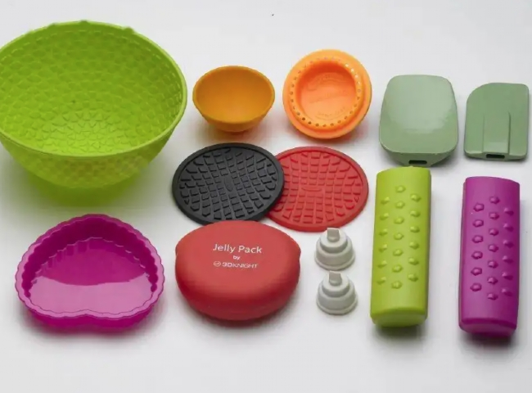

The plastics industry has most applications， including the use of nitrogen. Nitrogen is used in plastic manufacturing to prevent oxidation and discoloration and to help maintain the integrity of polymers. Nitrogen is also used as a propellant to aid in the injection molding process. These applications include gas-assisted injection molding， tank blanking and extrusion processes. Our tested and proven PSA nitrogen technology separates the nitrogen that is readily available in the air we breathe.

The air is 78% nitrogen; our system mechanically filters out the other gases and concentrates the nitrogen into a storage tank for your process. Clean， dry compressed air enters one of two adsorption vessels containing carbon molecular sieves (CMS). Smaller oxygen and residual molecules are adsorbed into the CMS， allowing larger nitrogen molecules to pass through and into a storage tank for later process use. After saturation， a second adsorption vessel comes online while the first one regenerates and releases its captured gas.

This type of injection molding uses nitrogen as an inert gas to push the polymer from the tank into the mold. This helps to completely fill the part and also reduces shrinkage. The nitrogen is pushed into the mold under high pressure， ensuring that the polymer reaches all areas of the mold. Nitrogen can also be used as a propellant for blow molding applications that require hollow parts. By using nitrogen as a propellant， you eliminate the polymer's ability to come into contact with oxygen， thereby reducing oxidation and discoloration of the polymer.

Our product range

1. Equipment capacity range

5 to 1000NM3/HR.

2. Purity of nitrogen

99% to 99.9998%

3.Dew point

-20 to -40 degree Celsius

4.Discharge pressure

5 to 25KG/CM2