**What is a water chiller?**

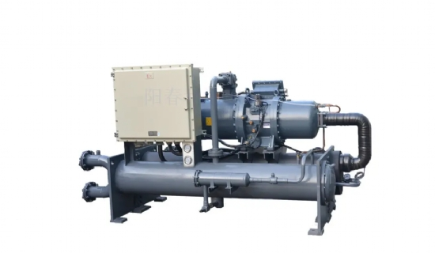

Chiller: is a water cooling equipment， chiller is a kind of cooling water equipment that can provide constant temperature， constant flow， constant pressure. The working principle of the chiller is to inject a certain amount of water into the machine tank first， through the chiller refrigeration system will cool the water， and then the pump will send the low-temperature cooling water into the equipment to be cooled， the chiller chilled water will take away the heat and then the temperature rises back to the tank， to achieve the role of cooling. Cooling water temperature can be automatically adjusted according to the requirements， long-term use can save water. Therefore， the chiller is a standard energy-saving equipment.

(A)， the cooling principle of the chiller.

The chiller system operates through three interrelated systems: refrigerant circulation system， water circulation system， and electrical automatic control system.

(B)， chiller refrigerant circulation system.

The liquid refrigerant in the evaporator absorbs the heat in the water and starts to evaporate， and eventually a certain temperature difference is formed between the refrigerant and the water， and the liquid refrigerant is completely evaporated into a gaseous state and then absorbed and compressed by the compressor (pressure and temperature increase). evaporator to complete the refrigerant circulation process.

Chiller refrigeration system basic components.

1， the compressor: the compressor is the core component of the entire refrigeration system， but also the source of power of refrigerant compression. Its role is to convert the input electrical energy into mechanical energy， the refrigerant compression.

2、Condenser: In the refrigeration process， the condenser plays the role of outputting heat energy and making the refrigerant condensed. After the high pressure superheated vapor from the refrigeration compressor enters the condenser， all the heat it absorbs in the working process， including the heat absorbed from the evaporator and the refrigeration compressor and in the pipeline， is transferred to the surrounding medium (water or air); the refrigerant high pressure superheated vapor condenses into liquid again. (According to the different cooling media and cooling methods， condensers can be divided into three categories: water-cooled condensers， air-cooled condensers， evaporative condensers.)

3， the reservoir: the reservoir is installed after the condenser， and the condenser is directly connected to the discharge pipe. The refrigerant liquid of the condenser should flow into the reservoir unimpeded， so that the cooling area of the condenser can be fully utilized. On the other hand， when the heat load of the evaporator changes， the amount of refrigerant liquid needed also changes， then， the reservoir will play the role of transferring and storing refrigerant. For small chiller refrigeration equipment system， often do not install the reservoir， but the use of condenser to transfer and storage of refrigerant.

4， filter drier: in the chiller refrigeration cycle must prevent the entry of moisture and dirt (oil， iron， copper)， the source of moisture is mainly the newly added refrigerant and lubricating oil contains a trace of water， or due to the maintenance system when the air enters and brings moisture. If the moisture in the system is not eliminated， when the refrigerant passes through the throttle valve (thermal expansion valve or capillary tube)， sometimes the moisture will solidify into ice because of the pressure and temperature drop， making the channel blocked and affecting the normal operation of the refrigeration equipment. Therefore， the filter drier must be installed in the chiller refrigeration system.

5， thermal expansion valve: thermal expansion valve in the chiller refrigeration system is both a flow control valve， but also a throttle valve in the refrigeration equipment， it is installed in the refrigeration equipment between the filter drier and evaporator， its temperature-sensitive package is wrapped in the outlet of the evaporator. Its main role is to make the high pressure room temperature refrigerant liquid in the flow through the thermal expansion valve throttle down， into low temperature low pressure refrigerant wet vapor (mostly liquid， a small part is steam) into the evaporator， in the evaporator vaporization heat absorption， and to achieve the purpose of refrigeration cooling.

6， evaporator: evaporator is relying on the evaporation of refrigerant liquid (actually boiling) to absorb the heat of the cooled medium heat transfer equipment. Its function in the refrigeration system is to absorb heat (or the output of cold). In order to ensure that the evaporation process can be stable and lasting， the evaporated gas must be constantly pumped away with the refrigeration compressor to maintain a certain evaporation pressure.

7， refrigerant: most industrial chillers used in modern industrial production use R22 or R12 as refrigerant. Refrigerant is the transporting agent in the refrigeration system， its main role is to carry heat， and to achieve heat absorption and exotherm when the state changes.