**8 Precautions to Consider for Critical Pipeline Safety**

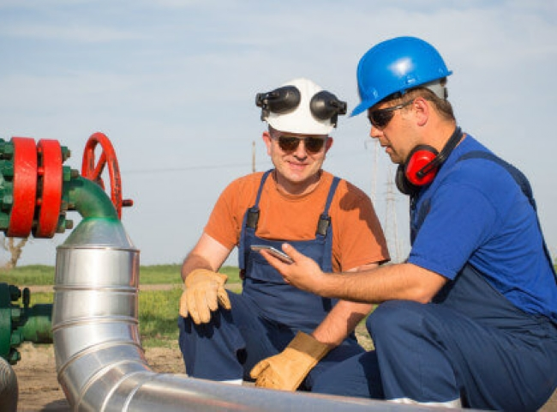

When dealing with high-pressure equipment， such as pipelines， there are always risks. Some of the risks involved in pipeline handling include overhanging loads and hazardous terrain， as well as the ubiquitous element of human error in operations.

All personnel must be aware of the necessary safety procedures to ensure proper and safe handling of equipment. These procedures will help minimize hazards， thereby reducing the accident rate on site.

8 Important Pipeline Safety Topics

Here are some important safety precautions for working on pipelines

1. Conduct frequent safety training

To increase employee awareness and enhance learning onsite， employers should schedule frequent safety training. During training， employees， supervisors and managers should all attend. Enhanced learning is an effective way to create a consistent mindset in each individual.

All training conducted in the United States must be consistent with national standards and industry best practices from recognized associations. For example， the American Gas Association provides pipeline safety guidelines for enhancing pipeline safety in the natural gas industry.

2. Foster a corporate safety culture

Safety is critical in pipeline facilities to prevent hazardous conditions that could cause injury to employees. Safety must come before work， not the other way around. It is the responsibility of managers and supervisors to instill this awareness in employees by setting an example， giving rewards， and implementing consequences when necessary.

All employees working in the field should have the authority to stop work， enabling them to stop procedures they consider unsafe.

3. Ensure proper pipeline excavation procedures

Proper pipeline excavation procedures must be carefully followed to prevent hazardous conditions on site. Excavators used should be serviced when appropriate and operators should receive adequate training. Explosions or environmental contamination may occur when excavators damage underground pipelines. Therefore， all buried utilities must be identified and marked before starting operations.

Operators may also call 181 to confirm when it is safe to begin excavation. Proper benching and tilting techniques are critical during excavation. osha requires that employees working in trenches 5 feet or deeper (4 feet deep in some states) should use a trench protection system.

4. use appropriate and adequate personal protective equipment when working in the field

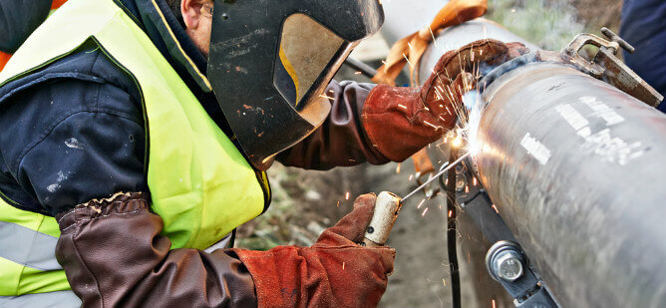

When working with heavy equipment such as pipelines， employees must use appropriate and adequate personal protective equipment (PPE). While PPE is widely considered the last line of defense against hazards， they can be the difference between employee safety and injury or death. PPE should cover a number of body parts， including the face (eyes)， hands and feet.

Standard PPE to ensure safety on site includes safety goggles， hard hats， safety boots (with steel toes) and gloves. Each employee is responsible for managing their own safety and the safety of others through the use of appropriate PPE to reduce the risks associated with working on the pipeline. PPE is especially important in pipeline cleaning services such as pipeline pigging or pipeline nitrogen purging where there are hazards from equipment and chemicals.

5. Ensure adequate training for operators of heavy machinery

All workers who operate heavy machinery such as excavators， forklifts and trucks should be adequately trained and briefed on proper work procedures and practices at the job site. Also， keep operation and maintenance manuals (OMMs) for the type of machinery they operate in a readily accessible place for employees.

Workers who have been adequately trained on one type of machine are not necessarily competent to use another. Avoid interchanging roles between workers to prevent unsafe conditions due to improper operation.

6. Inspect all tools used on site

Regularly monitor and inspect tools used on site， such as hand and power tools， for cracks， signs of deterioration， or wear to ensure they are in safe working condition. Repair or replace defective or broken tools immediately to prevent unsafe working conditions and injury to employees.

7. Use proper operating techniques

When working with heavy equipment such as piping， be sure to use proper operating procedures. Operators must follow the manufacturer's recommendations for handling equipment and avoid overloading. When necessary， use mechanical aids， for example， to prevent back injuries when lifting heavy， suspended objects such as pipes and fittings. Prepare a Job Hazard Analysis (JHA) prior to performing any activity. This document will inform all employees of the risks involved in performing a specific task so that they can remain safe at all times.OSHA has several safety standards for proper manual and machine-assisted lifting procedures.

8. Maintain proper pressure testing procedures

A basic safety precaution for working on pipelines is not to operate a pipeline for extended periods of time at more than its maximum operating pressure (MOP). Performing pipeline pressure tests at pressures in excess of the pipeline's pressure rating can compromise the integrity of the pipeline. Always follow the manufacturer's written test procedures to stay within safe limits.