The role of on-site nitrogen generator (PSA nitrogen machine， nitrogen equipment) in reflow soldering over the furnace

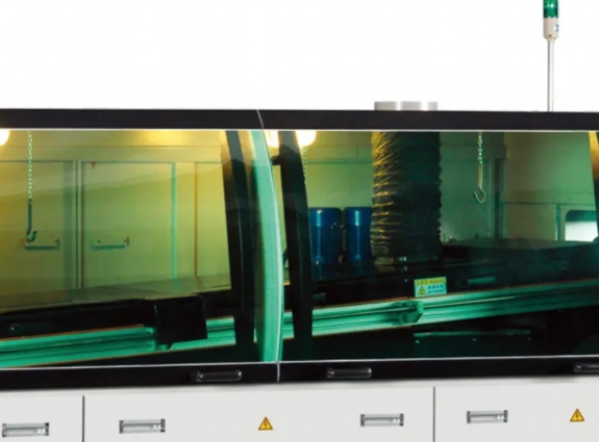
Reflow soldering over the furnace charging nitrogen role.
1， reduce oxidation (solder surface oxidation and PCB oxidation).
2、Improve the wettability of the solder.
1， to reduce the high temperature oxidation of solder: nitrogen is an inert gas， not easy to produce compounds with the metal， but also to avoid metal oxidation by air.
After filling nitrogen can reduce the concentration of oxygen and other possible pollutants in the reflow oven， reducing the oxidation of solder at high temperatures.
Reduce the oxidation of the solder surface: PCB double-sided over the furnace， the first side of the PCB over the furnace， the second side of the PCB also experienced high temperatures at the same time， the surface treatment of the circuit board will be destroyed by high temperatures. In particular， the use of OSP surface treatment of the board， after filling nitrogen can be in the first side of the reflow soldering to reduce the degree of oxidation of the second side of the surface treatment， so that it can be supported to the second side of the furnace and get the best soldering effect.
2， improve the fluidity and wettability of the solder: nitrogen environment， the surface tension of the solder will be less than the atmospheric environment， making the fluidity and wettability of the solder has been improved.
Of course filling nitrogen will be higher requirements for the chip factory process capability， cost tips， for a single panel or no BGA or small package device PCB， for cost considerations， do not do this requirement.
Nitrogen charging seems to be an optimization item， but the actual use also has some disadvantages.
Such as the wetting of solder is too good for some gold-plated terminals， the ability to climb the tin is too good， which may trigger the wick effect， but instead lead to poor functionality of the terminal， so it also needs to be adjusted in conjunction with the actual situation.
Nitrogen filling and stencil opening size， etc. are welding optimization items， but also need specific analysis of specific problems.

