**Mass flow controller (mass flow meter) working principle**

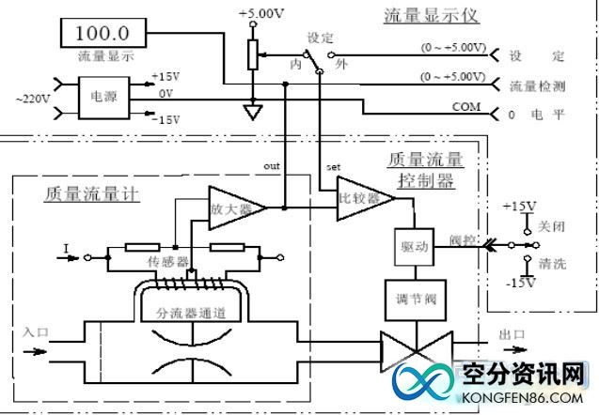

The mass flow controller consists of components such as a flow sensor， a splitter channel， a flow regulator valve and an amplification control circuit， while the mass flow meter consists of components such as a flow sensor， a separator channel and an amplification control circuit. When the gas flows through the mass flow controller (mass flow meter)， part of the gas passes through the flow sensor. The flow sensor uses the capillary heat transfer temperature difference calorimetry principle to measure the mass flow of gas (without temperature pressure compensation)， the detected flow signal is fed into the bridge， the bridge will convert the flow signal into an electrical signal， the electrical signal is amplified by the amplifier to 0 ~ 5 V， the amplified flow detection voltage is compared with the set voltage， and then the difference signal is amplified to control the adjustment valve， closed-loop control of the flow through the channel so that The flow rate through the channel is controlled in closed loop so that it is equal to the set flow rate. The shunt determines the flow rate of the main channel. The working principle of the MFC and the flow display is shown in Figure 3: