**Different types of air dryers and their applications**

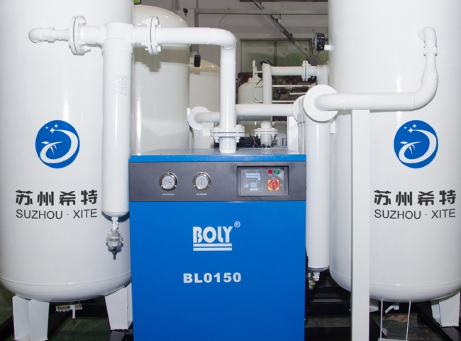

Nowadays， almost all industrial and commercial processes require the consumption of compressed air. This compressed air also contains water vapor and other impurities that need to be removed.

Air dryers are used to remove water vapor from compressed air because any excess moisture in compressed air can lead to compensation problems such as pipe corrosion and pneumatic system failure.

Hite is a renowned company that produces best quality and different types of air dryers with different applications.

Take a look at the different air dryers from Hite， which will facilitate the selection of the right air dryer.

Refrigerator dryer: It removes moisture by lowering the temperature and is suitable for any volume of products. It uses electronic system and LED. it is easy to operate and cost effective.

Heatless air dryer: It is fully automatic and dries moisture by adsorption. It is robust， inexpensive and has very low power consumption.

Internal heater dryer. In this system， the air temperature is 40 - 450 C and with the help of external heaters， it can reach 1800 C. Here， the repair is obtained by drying the air at high temperature and low pressure. These are the most intensive and simple.

Diversion dryer. Here， the moisture retention capacity is increased by allowing wet air to pass through the heater.

Blower Reactive: Here， the moisture retention capacity is increased by passing the restored air through a blower， which is then heated in a heating chamber. It is the most affordable.

Biogas dryer. It removes harmful water vapor and contains a dense steel base and a dew point (Dew point) of 30C when the inlet temperature is between 40-450.