**Extensive use of nitrogen in cement production**

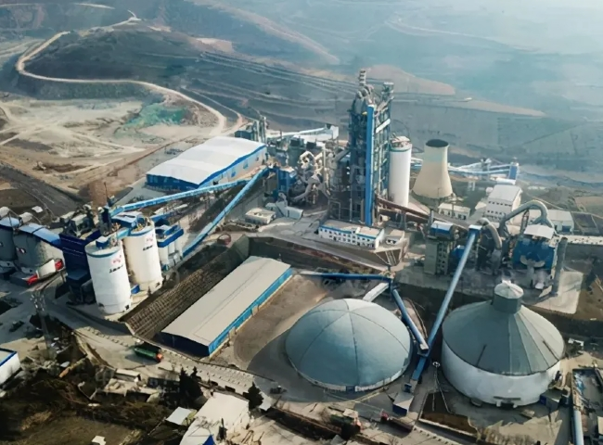

Gas Generation， Nitrogen， PSA Nitrogen Generator

Cement is a basic material for building and civil engineering construction. The output of the cement industry is directly related to the condition of the entire construction industry and therefore closely tracks the overall economic situation.

The three basic process steps in cement production are - preparation， mixing and grinding of raw materials into raw meal， which serves as feed for the kiln. - Calcination and combustion (sintering). This conversion process takes place in the cement kiln and its associated equipment. - Fine grinding， i.e. grinding of the clinker to produce cement.

After the mining， grinding and homogenization of the raw materials; the first step in cement production is the calcination of calcium carbonate， followed by the combustion of the resulting calcium oxide with silica， alumina and ferrous oxide at high temperatures， followed by grinding or milling with gypsum and other components to produce cement.

Clinker combustion takes place in a rotary kiln， which can be part of a wet or dry long kiln system， a semi-wet or semi-dry grate preheating kiln system， a dry suspension preheating kiln system， or a preheater/precalciner kiln system. The best available technology for the production of cement clinker is considered to be a dry kiln with multi-stage suspension preheating and precalcination.

A coal mill receives the coal feed and grinds it to a size suitable for introduction into the burner. This is a good example of the boundary considerations for isolating the kiln from the atmosphere. The coal is transported to the site under atmospheric conditions and then enters the kiln， which is isolated. At some point between these two extremes， a gas boundary must be established， either before or after the mill.

Currently， coal mills pose a safety risk because the friction during grinding heats the pulverized coal to the point of catching fire. To mitigate this risk， ambient air is blown through the mill to control the internal temperature. If the boundary is placed upstream of the coal mill， it will be filled with N2 instead of air. As a result， oxygen is not present to ignite the pulverized coal; in addition， the endothermic Budur or carbon gasification reaction limits the maximum temperature to 700 degrees Celsius. If the operating temperature of the mill is allowed to rise， the result of N2， steam and heat may lead to gasification. In this way， some of the electrical energy consumed by the mill can be transferred to the kiln as sensible heat. The advantage of this scenario is that the combustion characteristics of the fuel mixture can be varied to produce optimum conditions in the clinker formation zone.

Inert gas systems based on the fuel combustion process are used. However， there are many benefits to the application of nitrogen production with XITE PSA and more and more cement plants are using nitrogen instead of CO2.

As the main part of the combustion air nitrogen also represents the main part of the exhaust gas. Nitrogen it is not a pollutant.