**Some of the things you need to know about oxygen generators， on-site oxygen generators**

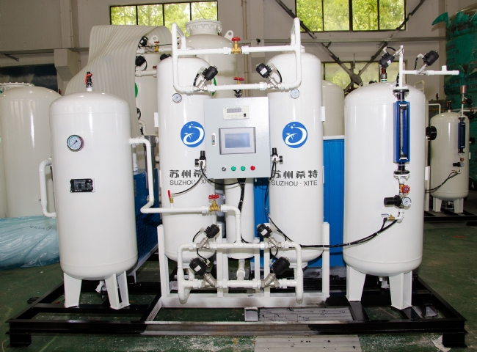

Are you looking for a good manufacturer of oxygen equipment? If you want to build your own oxygen production facility in your business， I suggest you first understand the basics of it. This will help to understand the details of the project and establish cost planning. Oxygen generators are used to compress the air that is extracted from the air.

When you build an oxygen production system， it consists of a device capable of producing high purity oxygen or nitrogen. These gases can have a purity of 99.7% and 99.99% respectively. These machines range from 30 m3/h to 5，000 m3/h. Moreover， you don't need to worry about the stability of these machines， as they have all been well tested under different conditions.

Equipment included in an air separation plant (oxygen generator or nitrogen generator)

A basic air separation system consists of the following units

1. Air Compressor
2. Air Purification Unit
3. Air Pre-cooling Unit
4. Air Separation Column
5. Expander
6. Liquid oxygen pump
7. Liquid oxygen filling system
8. And some other devices

Some features of air separation equipment (oxygen or nitrogen generators)

1. Excellent performance
2. Automatic control of water intake
3. Includes medium pressure technology
4. No gas waste due to high quality gas cylinders
5. Low power consumption， high output
6. Safe operation
7. Automatic temperature and pressure maintenance

Suzhou XITE， China is one of the air separation equipment suppliers in China and has started manufacturing and exporting oxygen equipment equipped with the most advanced features. Our oxygen equipment is manufactured with the latest technology and requires very less maintenance， has low maintenance and performs high in different weather conditions. Our oxygen generators take air from an air compressor and then separate oxygen and nitrogen.