**Oxygen generators for water treatment**

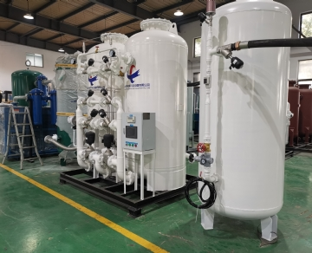

Oxygen generators allow you to produce your own oxygen when and where you need it. By using Pressure Swing Adsorption (PSA) to produce oxygen， the nitrogen is separated from the oxygen in the regular air.

At XITE， our oxygen generators have a container that absorbs nitrogen molecules， and as the oxygen molecules drift through the container， they are collected in an oxygen receiver tank. The oxygen receiver tank is connected to the oxygen generator and then pressure is released from the vessel to vent the nitrogen molecules back into the atmosphere. This cycle is repeated in a second vessel， providing a steady stream of gas to our oxygen generators.

Nothing is more important to the survival of every living thing on this planet than water. Access to clean water is a stepping stone to development. If people have access to clean water， they will be able to practice good sanitation and hygiene. However， access to clean water is becoming more difficult every day due to the increasing consumption of water worldwide. People are going to great lengths to obtain the quality and quantity of water they need to cook， drink， bathe， wash and grow their own food.

There are many applications for oxygen generators in water treatment systems， including.

Oxygen generators for ozone. An oxygen generator for ozone can be beneficial in many different situations. It works as an intake air for your ozone system. It is safe for the environment， which makes it suitable for effectively treating large volumes of water (including making sure clean drinking water comes out of the tap). A few examples of using oxygen generators to treat ozone include making suitable drinking water for animals， cleaning water for equipment， and replacing chlorine with ozone in swimming pools.

Oxygen generators for wastewater. Wastewater can come from many different sources - whether it's from an industrial building， a work office or someone's home， it can come from anywhere. By injecting oxygen into wastewater， the ability of bacteria to survive and regenerate can be greatly increased. Oxygen generation systems can provide years of self-sustaining oxygen production - meaning you don't have to deal with the ongoing costs of delivering oxygen produced at low temperatures. Wastewater oxygen generators are also very cost effective and low energy consuming. At Hite， we offer custom-engineered oxygen generators， oxygen container systems and oxygen generators (up to 95% purity).

At XITE， we are the experts in oxygen generators. Whether you are looking for a help with wastewater treatment， or ozone， we have the water treatment system you need. Our systems are designed to meet your specific purity， pressure and flow (flow) requirements.