**Nitrogen generator equipment used in pharmaceutical manufacturing**

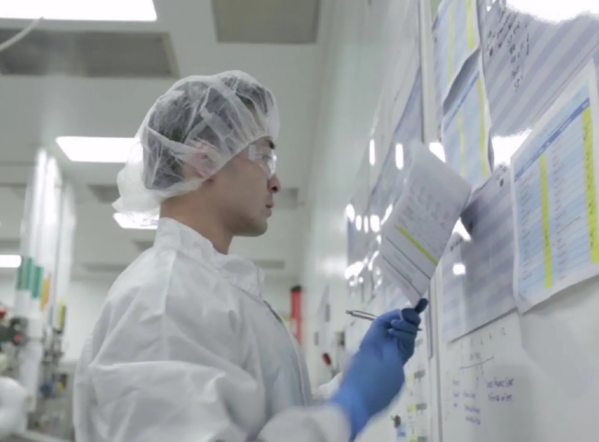

Category: Gas Generation， Nitrogen， PSA Nitrogen Generators

Nitrogen is essential in the pharmaceutical industry， from packaging to fire suppression， in a significantly fickle environment. Nitrogen is used to keep products dry and sterile to improve their durability. Nitrogen is also used to reduce the amount of oxygen in severe combustion situations. Previous nitrogen generators did not provide sufficient purity for pharmaceuticals.

Transfer High-pressure nitrogen can be used in applications where substances are safely transferred from one container to another. This efficient solution accelerates the process without causing any dissolution or buildup of substances. Purge Manufacturing and analytical equipment can be purged with nitrogen to remove oxygen and water vapor from the process line， which can improve product quality and reduce the need for further conditioning treatments. Jacketing The final drug product must be stored in an appropriate manner to ensure that humidity and oxygen do not affect the product and that the powder does not agglomerate. Covering with nitrogen provides an inert atmosphere that inhibits airborne contaminants such as moisture and bacteria. Nitrogen will also provide a cover that protects potentially reactive materials from contact with oxygen， thus maintaining quality.

Many pharmaceutical products cannot withstand any form of thermal sterilization， in which case aseptic filtration followed by packaging in pre-sterilized containers in a cleanroom environment is the best solution. Because of the complexity of aseptic filtration/filling operations， environmental controls are required to maintain standards. Nitrogen can be used to provide a suitable atmosphere and for filter integrity testing.

Internal nitrogen generators based on pressure swing adsorption technology require much less energy and therefore have much lower carbon emissions compared to fractionation of air and transport of gas from distillation sites. Significant energy is consumed during partial distillation and additional energy is required to transport the nitrogen to the end user. In contrast， an in-house PSA system requires only one source of compressed air. Since nitrogen is generated locally and requires very little energy， the conversion to PSA-generated nitrogen is likely to result in significant "green" credits for pharmaceutical companies that are not located near a fractionation plant. The green credit also comes from the fact that there is no longer a need to transport liquid nitrogen over long distances. In addition， by using an energy recovery type system with a water-cooled air compressor， a significant amount of the electricity used to generate nitrogen can be recovered.