**Application of nitrogen generator in brewery: the role and benefits of nitrogen in brewery**

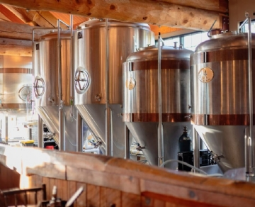

For centuries， beer has been one of the most popular and popular alcoholic beverages in the world. Whether you're holding a celebration or relaxing in a restaurant with a cold beer after a long day， beer is an essential drink for many families.

However， apart from beer tasters and brewers， few people are curious about the process of brewing various types of beer， let alone the important role played by nitrogen.

Benefits of installing on-site nitrogen generator (nitrogen generator) for Brewery:

Why is the on-site nitrogen generation system (nitrogen generator) important to the brewery?

From large breweries to micro breweries， every enterprise producing beer by itself can benefit greatly from the installation of on-site nitrogen generator (nitrogen generator). Traditionally， a mixture of nitrogen and carbon dioxide (CO2) has been used at all stages of the beer production process， including preventing beer oxidation and cleaning cans between applications. Most brewers hardly know that most of the carbon dioxide used in these processes can be replaced by pure nitrogen.

Nitrogen can also be used to transfer beer from one tank to another and pressurize the beer barrel. It can also be used for bottled and canned beer before shipment to help extend the shelf life and maintain product purity.

The role of nitrogen in beer brewing

The brewing process consists of four stages:

Malt processing includes combining a series of elements such as starch， protein， vitamins， enzymes and minerals to make the basic material of starch ingredients.

Saccharification is the process of mixing malt with hot water to activate enzymes， so they break down starch into natural sugar and separate it from the ingredients. This produces wort.

Next， boil the wort to a certain temperature. The change in temperature depends on the type of beer and the ingredients added.

Finally， the mixture is cooled and divided into equal parts， and then yeast is slowly added to start the fermentation process.

Due to its inertia， nitrogen is an ideal gas for various applications in beer brewing， including:

1. After each batch is removed， wash the tank while preparing the next batch to remove residual wort， saccharification and malt essence

2. Prevent cross contamination between batches

3. Replace oxygen and carbon dioxide in the tank during beer transportation

4. Pressurize barrels， bottles and cans to maintain and extend product freshness， quality and shelf life

5. Add nitrogen to beer to increase carbonation and flavor

Benefits of using on-site nitrogen generator in brewery

The on-site nitrogen generator of the brewery has the following advantages:

1. Reduce carbon emissions by eliminating the need to transport nitrogen from different locations

2. Reduce carbon emissions by reducing or eliminating the use of carbon dioxide

3. Compared with the traditional nitrogen supply scheme， the cost of nitrogen is significantly reduced

4. Eliminate the risk of nitrogen supply shortage and delayed delivery

5. Reduce carbon emissions

Increase safety measures by minimizing the risks involved in transporting and handling nitrogen in liquid dewars or nitrogen cylinders