**Air compressor coupler and accessories**

Quick disconnect connectors are the fastest， simplest and most reliable way to connect air hoses to air compressor tools， tire inflators and air blowers

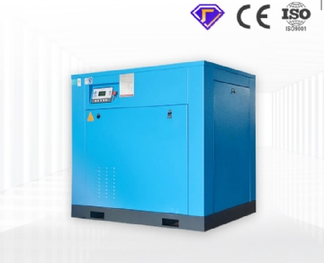

All quick disconnect connectors have similar connections and functions:

* A hardened ball or pin that fits into the slot in the coupler plug and secures it to the seal.
* This connection also allows the connector to rotate， thereby reducing kinks and twisting of the hose.
* When the coupler is retracted， the sliding sleeve releases the locking ball， allowing the plug to be inserted or removed. When released， the coupler automatically returns to the locked position.
* The automatic shut-off valve in the coupler is sealed immediately upon separation and does not need to be closed separately.

|  |  |
| --- | --- |
|  |  |

There are two main types of air compressor couplers: automotive and industrial. The following table shows how to identify the connector styles you own. As you can see， industrial style couplers have two stripes through accessories， while automotive style has only one. On the plug， the industrial style head is slightly longer than the car.

|  |  |
| --- | --- |
|  |  |

Amflo also produces two types of combined couplers， one with a female end and one with a male end. The combined coupler will be suitable for automotive or industrial style.