An effective way to make hydrogen on site

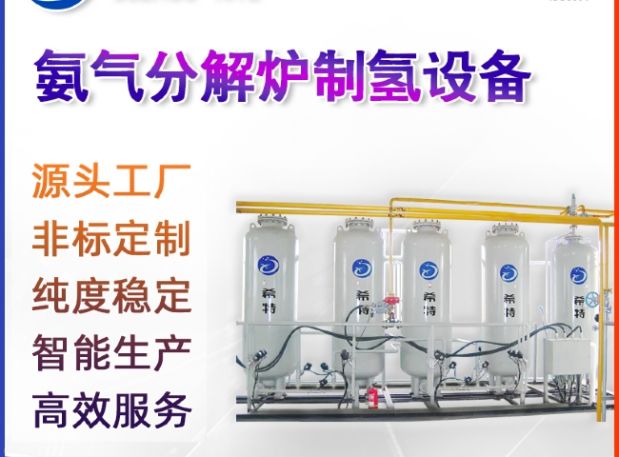
Hydrogen fuel is a clean energy carrier that has the potential to make a significant contribution to global decarbonization. The low bulk energy density of hydrogen - either in compressed gas or liquid form - makes hydrogen storage a complex issue in most applications. This limitation is felt most strongly in the area of on-board storage， but there are also problems in the delivery and distribution of hydrogen. The low energy density of hydrogen may be one of the professional barriers to implementing hydrogen fuel cell vehicles.
A number of chemical， solid-state and other methods have been investigated and are currently being studied that may lead to higher energy storage densities. However， little attention has been paid to the possibility of using ammonia (NH3) as a medium for storing hydrogen on vehicles or as a distribution medium.
The use of ammonia (NH3) as a hydrogen carrier appears to be a potential alternative for energy storage and delivery. Since ammonia has a high hydrogen bulk density and has been manufactured in large quantities for the past 75 years for use as a fertilizer， most storage and transportation infrastructure is already in place.
Ammonia Crackers - An Effective Way to Produce Hydrogen On-Site
Ammonia cracking is one of the most cost-effective methods of producing hydrogen on-site for industrial purposes. Cracking can be used to convert ammonia into a combination of nitrogen (N2) and hydrogen (H2)， which can subsequently be utilized as a fuel. The operation is maintained at a temperature of 850°C in an electrically heated furnace. The furnace contains a nickel catalyst and a centrifugal casting retort mounted in the center of the furnace. In this stage， the cracking of ammonia is carried out in the presence of the nickel catalyst. At a dew point of (-)30°C， the method separates its basic composition into 75% hydrogen and 25% nitrogen. Since nitrogen is usually inert， this mixture is considered pure hydrogen. As a result， ammonia cracking has become the most cost-effective， tested and reliable source of on-site hydrogen production for many small and large industries. After the ammonia cracking plant， a molecular sieve purifier reduces the residual ammonia content and produces a very dry gas.
Applications
Ammonia crackers are widely used in the following industrial processes.
? Heat treatment furnaces in annealing， sintering and galvanizing processes
? Reduction of furnace atmosphere
? Bright annealing of stainless steel
? Bright annealing of carbon steel
Hydrogen transport methods - centralized vs. non-centralized
When hydrogen is transported， similar restrictions that cause problems with storing hydrogen on vehicles arise. The decentralized method， where imported ammonia is brought to the point of use and cracked on site， is expected to be more cost effective than the centralized method， where imported ammonia is cracked centrally and then transported as hydrogen to the point of use.

