Classification and properties of industrial gases

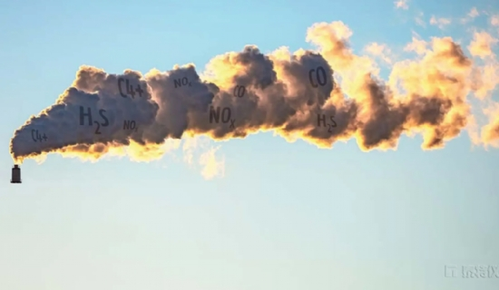
Classification and characteristics of industrial gases. Industrial gases can be divided into 4 categories according to their chemical properties: (1) highly toxic gases， which are extremely toxic and can cause poisoning or even death when invaded into human body. Such as chlorine gas， ammonia， etc. (2) Flammable gases， with easy combustibility and chemical explosion risk， and have a certain degree of toxicity. Such as hydrogen， acetylene， etc. (3) Combustible gases， with the ability to ignite， but do not burn themselves， there is a risk of expanding the fire， such as oxygen， etc. (4) non-flammable gases， asphyxiating to people， stable in nature， non-combustible， such as nitrogen， carbon dioxide and argon. National standard GB13690-1992， the above four gases are divided into three subcategories， namely， Class 2.1 flammable gases， Class 2.2 non-flammable gases (including combustion gases)， and Class 2.3 toxic gases.
Industrial gases can be divided into industrial pure gases of a single species of gas and industrial mixtures of binary or multi-gases according to their components. In the national standard "Classification of Bottled Compressed Gases" (GB16163-1996)， industrial pure gases are classified according to their physical state and critical temperature in cylinders， and grouped according to their chemical properties， combustibility， toxicity and corrosiveness. Category 1 is permanent gas， whose critical temperature 〈-10℃， which is gaseous when filled and during storage and use at the allowed working temperature， divided into two groups a and b: group a is non-combustible non-toxic and non-combustible toxic gases (including oxygen， nitrogen， argon， etc.)， group b is combustible non-toxic and combustible toxic gases (including hydrogen， etc.). Group 2 is liquefied gases， whose critical temperature is ≥ -10 ℃， including high-pressure liquefied gases and low-pressure liquefied gases. Among them， the critical temperature of high-pressure liquefied gases ≥ -10℃ and ≤ 70℃， which are liquid when filled， but evaporate to gaseous state as the temperature rises to the critical temperature during storage and use at the allowed working temperature， divided into three groups of a， b and c: group a is non-flammable non-toxic and non-flammable toxic gases (including carbon dioxide); group b is flammable non-toxic and spontaneous flammable toxic gases; group c is easily decomposed or polymerized flammable gas. The critical temperature of low pressure liquefied gas is 〉70℃， which is liquid at the time of filling as well as during storage and use at the permitted working temperature， and is also divided into three groups of a， b and c: group a is non-combustible and non-combustible toxic and acidic corrosive gases (including chlorine); group b is combustible non-toxic and combustible toxic and alkaline corrosive gases (including ammonia); group c is combustible gases that are easily decomposed or polymerized. Group 3 is dissolved acetylene， the gas dissolved in the cylinder solvent under pressure， only group a: flammable gases (including acetylene) that are easily decomposed or polymerized. This classification is the basis for the preparation of gas mixtures.
Industrial gas mixtures are new species that have appeared in the last two decades and are very versatile， but their classification has not yet been standardized. Industrial gas mixtures include natural synthesis and pure product preparation. According to its state， it is divided into gaseous mixture and liquid mixture. According to its main hazardous components， it can be generally divided into flammable mixture， spontaneous combustion mixture， highly toxic mixture and corrosive mixture.
The common physical properties of industrial gases can be summarized as follows: compressibility and expansion. When the temperature of a certain amount of gas remains basically the same， the larger the pressure is added， the smaller the volume will become， and if the pressure is continued， the gas will be compressed into a liquid， which is the compressibility of the gas. Industrial gases are usually stored in cylinders in a compressed or liquefied state. The contents of this book also focus on the safety technology of filling industrial gases and inspection of gas cylinders. When gases are exposed to light or heat， the temperature rises， the thermal movement between molecules intensifies， and the volume increases. If in a certain container， the higher the temperature of the gas exposed to heat， the greater the pressure formed after its expansion， which is the expansion of the gas exposed to heat. Compressed gas and liquefied gas in containers， such as high temperature， sunlight， gas is very easy to expand， resulting in a lot of pressure， when the pressure exceeds the pressure strength of the container， it will cause an explosion. Therefore， industrial gases have a great risk of explosion.

