**Large chemical company’s 150 cfm nitrogen generator plant in operation**

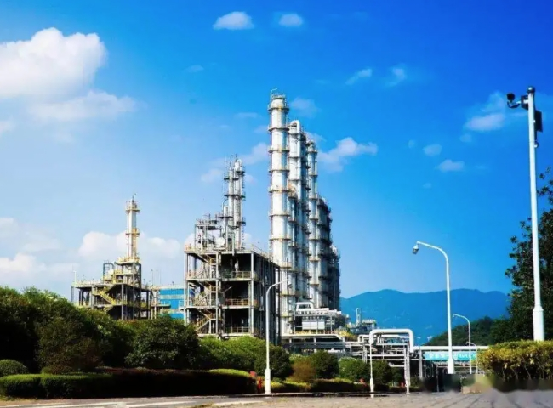

Gas Generation， Nitrogen， PSA Nitrogen Generator

We have supplied PSA nitrogen generation equipment to different locations. They are very happy with the operation of these units and we thank them for their continued trust in XITE. We are proud to be able to provide ongoing support through our PSA nitrogen plants.

Nitrogen production using variable pressure adsorption (PSA) technology on carbon molecular sieves (CMS) is considered a proven， cost-effective， and efficient method of nitrogen production that can meet most purity and flow requirements. The increasing efficiency of PSA-based nitrogen production facilities is driven by enhanced CMS materials and process improvements. This paper provides an overview of the fundamentals of PSA nitrogen production， with a special focus on innovative practices and improved CMS materials. These advances have helped to continually improve the performance of PSA systems， providing facility operators in the chemical processing industry with a reliable， cost-effective method of producing high-purity dry nitrogen on-site.

Chemical and resin production processes require large amounts of nitrogen. Nitrogen is an excellent inert gas and is used extensively in this industry， including the preservation of chemicals and the prevention of oxidation of raw materials. Many chemical industries handle volatile and flammable chemicals. The elimination of oxygen is a key issue， as the absence of oxygen largely mitigates the fire hazard.

|  |  |
| --- | --- |
| MODEL | CAPACITY NM3/HR |
| GAZ-MS-150 | 150 NM3/HR |
| Nitrogen Purity | 99% |
| Pressure | 6 Bar |