**Will oxygen absorption by oxygen generator affect the oxygen content in the room?**

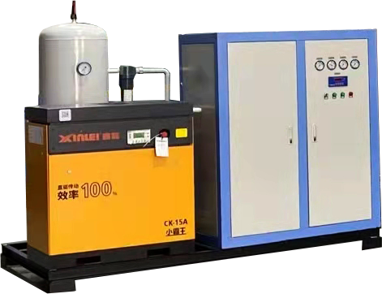

In recent years， household oxygen generator has entered every family and become a necessity for family life. Will oxygen use up the oxygen in the house? This is the concern and concern of people who take oxygen. As long as you understand the generation of oxygen and the working principle of oxygen generator， you won't have this concern.

Today， Xiaobian will share this question with you. First of all， the oxygen produced by the oxygen generator is extracted from the air where we live through pressure swing adsorption technology. The oxygen generator is filled with molecular sieve， which can adsorb nitrogen in the air when pressurized， and the remaining unabsorbed oxygen is collected and becomes high-purity oxygen after purification. In other words， the molecular sieve oxygen generator does not consume the oxygen in the air. It is only used as a porter to move from the house to the oxygen generator and collect it for oxygen users. The oxygen used by oxygen users also exists in their own ambient air， that is， if you use it or not， the oxygen is there. Giving more oxygen to oxygen users will not affect the oxygen in the environment or consume it.

In fact， such concerns are superfluous. When we do not use the household oxygen generator， we directly inhale the oxygen in the air and discharge the carbon dioxide reaction. When we use the household oxygen generator to inhale the oxygen， we also inhale the oxygen and discharge the carbon dioxide reaction. In addition， during our daily breathing， we really inhale very little oxygen， and most of the oxygen returns to the air through breathing. The use of household oxygen generator to absorb oxygen is just to separate the oxygen in the air and make the oxygen we inhale more pure.

And the oxygen inhaler only consumes oxygen when inhaling， but does not consume oxygen when exhaling. Secondly， the oxygen inhalation environment used by oxygen inhalers - the room also does not need to be closed， and there is no completely closed environment. In the process of oxygen inhalation， with the entry of outside air， we will also supplement the oxygen in the room， which can completely balance the oxygen consumed by oxygen inhalers.

To sum up， oxygen inhalation will not consume the oxygen in the house. Please feel at ease!