**What kind of piping is needed for compressed air systems?**

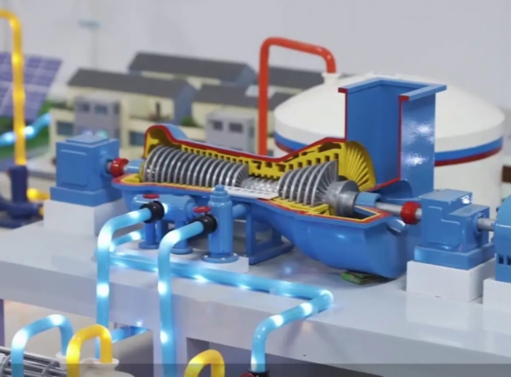

Compressed air is essential for all types of industries. So make sure all of your components， air compressors and parts are working properly to keep your business running properly. Most people forget that even though your compressor is pushing air out， your piping carries a lot of responsibility. Your compressor spends a lot of time compressing and cleaning， so don't contaminate it with the wrong piping!

No: PVC piping.

Unfortunately， while this type of piping is considered the most common because it is easy to get， it can also be considered dangerous. PVC eventually becomes brittle over time when used in compressed air systems， leading to cracks， breaks and even shattering. These failures， combined with air under pressure， can be potentially fatal due to razor-like shrapnel in the air. Using PVC is an OSHA violation， which means you could incur hefty fines.

No: rubber hose lines.

Rubber hoses can be a temporary solution， but they are not energy or cost effective. When you use rubber hoses， you tend to experience pressure drops because the hose is not stiff. In addition， over time， your hoses will start to develop odors as the rubber breaks down， which will eventually make its way into your product.

In addition， the installation and modification process is easy with a variety of different sizes of push-in connection fittings.

14mm pipe is a true push-pull fitting

20-40 mm pipes are pre-tightened

Pipes 50 mm and above need to be pushed in and wrenched tight