**How are Chinese crabs and mud crabs farmed?**

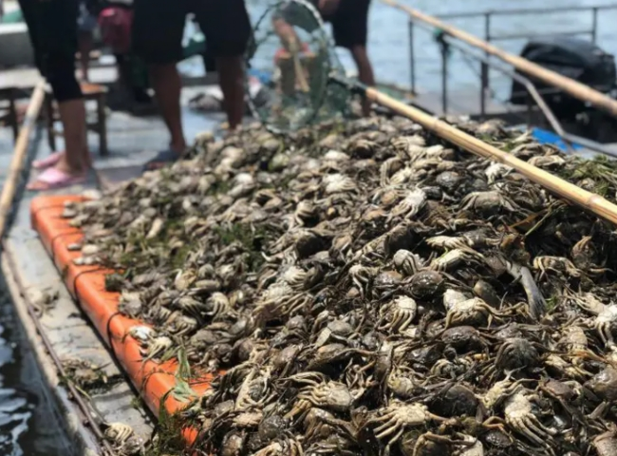

Types of crab farming -

In most commercial crab farming systems， there are two adapted farming methods. They are the grow-out system and the fattening system. The grow-out system is a farming method that involves the growth of young crabs until they are 6 months old. At 6 months， these crabs are considered marketable in terms of size and weight. This type of farming is pond-based.

The fattening system involves pond fattening or cage or pen fattening. In the former system， ponds with a tidal depth of about 1.5 m are selected. The latter method is carried out by using floating cages， pens and bamboo cages placed in ponds with appropriate tidal currents. Pond fertilization systems are relatively more profitable than planting systems because the process takes less time. The two most important parameters when farming or fertilizing systems are - soil and water quality. A sandy bottom does not allow for burrowing， so the most suitable soil type for crab farming is sandy or sandy clay. The ideal water quality for crab farming is brackish water. Mud crabs have a high tolerance for salinity fluctuations.

Pond construction-

Ponds play a key role in mud crab farming. Small tidal ponds with a depth of 0.5-1 m can be used. Ponds should be constructed with care. Parameters necessary for high production need to be carried out to prevent any defects.

Sluice gates should be used to regulate the flow of tidal water (flow). Installing bamboo screens on the sluice will prevent crabs from escaping. Harmful pathogens that may affect the health of crabs can be avoided by draining the water before liming the pond.