**Air Compressor Safety Relief Valves: Everything You Need to Know**

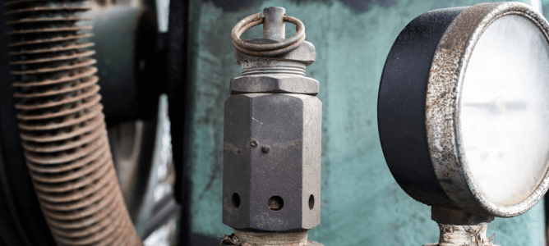

An air pressure safety relief valve is an important component in an industrial air compressor to prevent overpressurization. It is a safety measure that automatically opens when the air pressure in the system exceeds a preset limit， allowing excess air to escape and preventing potential damage to the equipment or the system itself. This controlled release ensures that the pressure remains within safe parameters.

What is an air compressor pressure relief valve and how does it work?

The function of an air relief valve is to relieve excess pressure in a compressed air system to prevent potential overpressurization and equipment damage. When the pressure in the system exceeds the valve's predetermined setting， the pressure relief valve opens， allowing the excess air to escape.

This controlled release reduces the risk of system failure and ensures that pressure remains within safe limits. Once the pressure returns to an acceptable range， the relief valve closes and normal operation resumes. This mechanism protects the integrity of the compressed air system and its components， increasing safety and optimum performance.

Air Compressor Safety Relief Valves - Maintenance Tips

Maintaining your air compressor safety relief valve is important to ensure safe and efficient operation of your system. Below are some maintenance tips for air compressor safety relief valves:

Periodic Inspection: Perform a routine visual inspection of the safety relief valve for signs of damage， corrosion or wear. Make sure the valve is free of debris and any obstructions that could prevent it from functioning properly.

TEST VALVES: Periodically test safety relief valves to ensure they open and close as designed. Follow the manufacturer's recommended frequency and procedures for testing. This helps to identify any potential problems before they become serious.

VERIFY PRESSURE SETTINGS: Periodically verify that the pressure settings on pressure relief valves meet the specifications provided by the manufacturer. Incorrect pressure settings can jeopardize the safety of the entire system.

CLEANING: Keep the area around the relief valve clean to prevent dust， dirt or debris from entering and interfering with its operation. Clean the valve and its surrounding space regularly to ensure optimum performance.

RECORD MAINTENANCE: Keep records of all maintenance activities performed on the safety relief valve. Recording air compressor audits， tests， adjustments， and any replacements will help establish a comprehensive maintenance history and help track the performance of the valve over time.

REPLACE WHEN NECESSARY: If any signs of wear， damage， or malfunction are found during inspection or testing， the safety relief valve should be replaced immediately. Delaying replacement can affect the overall safety and life of the air compressor system.

Follow manufacturer's guidelines: Follow the manufacturer's guidelines and recommendations for maintenance， inspection， and testing. Different types of safety relief valves may have specific requirements， so it is important to follow the guidelines provided by the valve manufacturer.

TRAIN PERSONNEL: Ensure that personnel responsible for air compressor maintenance are adequately trained in safety relief valve procedures. Training should include proper inspection techniques， testing methods， and adherence to safety protocols.

CONSULT AN EXPERT: If there is any uncertainty or a specific problem arises， consult an expert or the manufacturer for guidance. Seeking professional advice will ensure that maintenance is carried out correctly and that any potential problems are dealt with in a timely manner.

Emergency shutdown procedures: Familiarize staff with emergency shutdown procedures in case the safety relief valve needs to be activated. Proper training in responding to emergencies enhances overall safety measures.

By consistently following these maintenance tips， you can contribute to a safe and reliable compressed air system by ensuring that your air compressor's safety relief valve operates effectively. Regular inspections， air compressor testing and adherence to manufacturer guidelines are key components of a comprehensive maintenance strategy.