**Principle of plateau PSA oxygen generator**

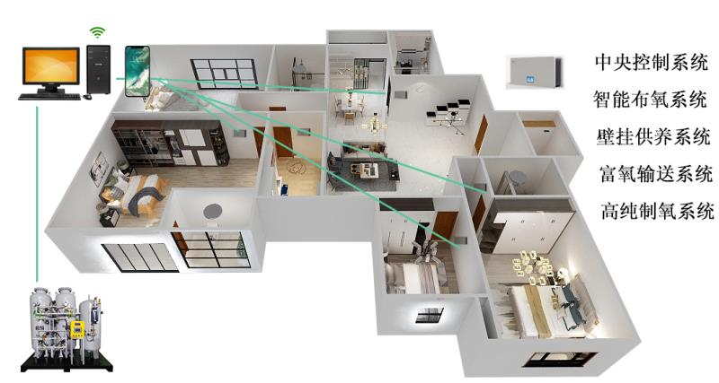

Principle of plateau oxygen production: the Daoyi oxygen generator adopts the world's advanced principle of pressure swing adsorption. It takes air as raw material without any additives. At room temperature， the external air is pressurized by the compressor， and 78% of nitrogen and 21% of oxygen in the air are separated through physical adsorption. At the same time， various impurities are removed， and dust-free， sterile and High purity oxygen in line with national medical standards. Its main core components are imported products， which ensures the reliable operation of the oxygen machine on the plateau and the purity of oxygen.

characteristic:

1. With air as raw material， without any addition， safe and no side effects;

2. Oxygen can be produced without leaving home; Low power consumption and low cost of oxygen production;

3. The whole set of gas circuit is controlled by low-pressure system program， and the operation is safe and reliable;

4. Stable performance and low maintenance cost;

5. Continuous oxygen supply， free surge stop， adjustable flow， ready to use and ready to make;

6. Simple operation， stable performance and low noise;

7. "Atomization" and "purification" devices can be selected， and oxygen inhalation and atomization therapy can be carried out at the same time;

8. With remote control and timing functions;

9. It has the functions of oxygen concentration monitoring and power-off alarm;

XITE oxygen generator is made by. At present， its products have been widely used in more than ten provinces and regions such as Shandong， Jiangsu， Sichuan， Tibet， Fujian and Chongqing. It is widely used in administrative office centers， banks， hotels， KTV， foot therapy， Internet cafes， fitness centers， teahouses， health clubs and various office places， bringing health to consumers and rich returns to operators. The products have been tested by the State Administration of quality and technical supervision and relevant departments. All technical indicators meet the relevant standards issued by the state， and the product technology and structure are ahead of similar domestic products.