**Application of PSA technology in nitrogen and oxygen generators**

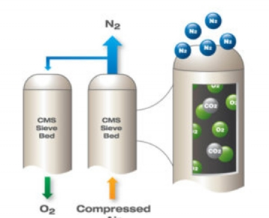

Any enterprise that uses more than one bottle of nitrogen or oxygen per week should consider using on-site nitrogen or oxygen generators. Hitler's on-site nitrogen and oxygen generation system has actually provided services to enterprises all over the world. These nitrogen and oxygen generators are not only more convenient than batch delivery of gas tanks， but also enable enterprises to recover the cost of field equipment within 12 to 15 months.

Customized on-site oxygen generator

After our custom design， the on-site gas generator can meet the needs of each customer. Generator sizes range from 2 cubic meters to larger， depending on gas volume and purity requirements.

This is a cost saving solution

This kind of input to produce nitrogen or oxygen on site saves a lot of money for the enterprise， because it saves the transportation and purchase costs required to buy bulk gas.

Convenience brought by pressure swing adsorption (PSA) technology

When the output of the on-site gas system is connected to the air supply of the enterprise (the air compressor system is available)， the enterprise has the ability to produce unlimited supply of nitrogen or oxygen. This is achieved through pressure swing adsorption technology. The use of PSA provides enterprises with the convenience of producing nitrogen or oxygen on demand， which fundamentally eliminates the waiting time related to the purchase of gas.

Working principle of PSA

The air around us contains about 78% nitrogen， 21% oxygen and 0.9% argon (the rest is composed of other gases). Pressure swing adsorption (PSA) technology aims to pass Carbon molecular sieve (nitrogen) or zeolite (oxygen) the process of separating nitrogen or oxygen from the rest of air. The carbon molecular sieve attracts (adsorbs) oxygen under high pressure and allows nitrogen to flow to the receiving tank. Zeolite has the same function as oxygen molecules in our oxygen generator， which is the best production process of nitrogen and oxygen generator.

Production process through PSA pressure swing adsorption technology

Our nitrogen and oxygen generator system consists of two tanks， each containing an adsorption screen material:

1. When the high-pressure air enters the first tank， it passes through the molecular sieve and adsorbs oxygen or nitrogen according to the type of generator and the required output gas.

2. Then guide the gas to the buffer tank or air storage tank.

3. Just before the first tank is fully saturated， the air is redirected through the second tank， where the same process occurs.

4. Once the process is completed， the first oxygen or nitrogen generator tank is discharged into the atmosphere to release the exhaust gas from the sieve.

5. To complete the regeneration of the first tank， it is necessary to purge it with a small amount of process gas.

6. The whole process continues to operate in the oxygen or nitrogen generator until the enterprise's demand for process gas is met.

Life of carbon molecular or Zeolite Sieve

Under general operating conditions (i.e. clean and dry feed air supply)， carbon molecular sieve or zeolite sieve can be used indefinitely.

Productivity of PSA oxygen generator

The purity of nitrogen or oxygen required by enterprises will affect the productivity of pressure swing adsorption (PSA). The amount of feed air passing through the screen increases slightly， and the PSA generator can produce a much larger process when the purity is 95% than that when the purity is 99.9%.