Oxygen is vital for life-saving treatment

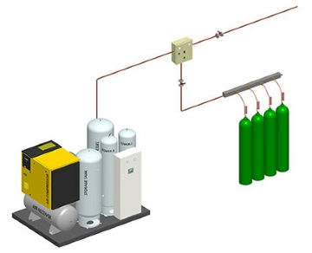
We know that more than 65% of the body is oxygen. Oxygen is necessary for respiration and is the cycle that transfers energy from glucose to cells. Every cell in our body needs oxygen. As we breathe in air， oxygen atoms enter our lungs and pass through the lung separators into our bloodstream. Since we really want oxygen to endure as a result， the significance of oxygen in the field of health care cannot be underestimated. Oxygen is an irreplaceable and essential life-saving drug， but most clinicians and most patients do not see it as a medicine. As a result， the utilization of clinical oxygen in the last century has been driven by habit， practice and the "precautionary principle" rather than scientific principles.
Industrial vs. medicinal oxygen Both industrial and medical oxygen is available on the market. Medical oxygen differs significantly from industrial oxygen in terms of purity and quality. Therefore， industrial and medical applications are not interchangeable.
Industrial oxygen is not intended for human use. Only medical oxygen that has been tested to meet the allowable requirements for identity， purity and content， and that has been produced， stored and dispensed in accordance with best practices， can be provided to patients. Uncertainty in the purity and content of industrial oxygen， the potential for particulate and microbial contamination， and improperly planned execution and controlled production， storage and distribution procedures may pose unacceptable risks to patients.
Medical oxygen can be manufactured by a variety of methods. The purification values of pharmaceutical oxygen vary depending on the source and method of manufacture.
For oxygen produced by the air liquefaction process， the International Pharmacopoeia requires oxygen to be not less than 99.5% v/v O2.
For variable pressure adsorption (PSA) plants， the World Health Organization's Interim Guidance Technical Specification for Variable Pressure Adsorption Plants states." Variable Pressure Adsorption technology produces 93% ±3" of medical oxygen from ambient air.
For oxygen concentrators， the WHO-UNICEF Technical Specification and Guidance for Oxygen Therapy Equipment states that "Oxygen concentrators should include the delivery of low-flow， uninterrupted， clean and concentrated oxygen (>82%) from room air (21%)"
Use of oxygen throughout the health system Oxygen is an essential component of medicine. Respiratory diseases， such as COVID-19 and pneumonia， are treated with oxygen by medical specialists. Oxygen is also needed for surgery and trauma. The elderly， pregnant women and newborns all require oxygen on a regular basis. Medical oxygen is required at several levels of the health care system. The following units in the healthcare system require oxygen consumption.
Primary health care
General wards
Emergency transport
Labor and delivery rooms
Surgical Units
Intensive Care Unit (ICU)
Specialized Hospitals
Outpatient Department
Hyperbaric Oxygen Chamber

