**PSA on-site oxygen generator produces 99% high purity oxygen**

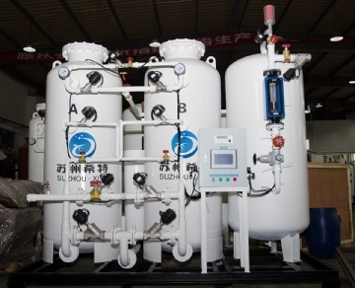

For years， XITE industrial oxygen generators have been producing 99% oxygen using PSA technology. Our company holds the patent for this breakthrough. Every day， our PSA oxygen systems are meeting the demand for medical oxygen in China， India， Myanmar， Brazil and other countries where hospitals and healthcare providers use only 99% oxygen. These industrial oxygen generators provide oxygen that is as reliable and low maintenance as our standard purity models. This oxygen purity used to come only from bulk suppliers， but times have changed.

How 99% Oxygen Generators Work

The 99% PSA oxygen generator is a multi-stage system that starts with a 95% oxygen generator. The 95% oxygen is then processed through a second stage to produce 99% oxygen and passes through the oxygen booster again in the final stage. The gas is then present at the desired pressure in a tank ready to power applications requiring the highest purity of oxygen.