**Pepsi is copying the craft beer industry’s approach to adding nitrogen by producing**

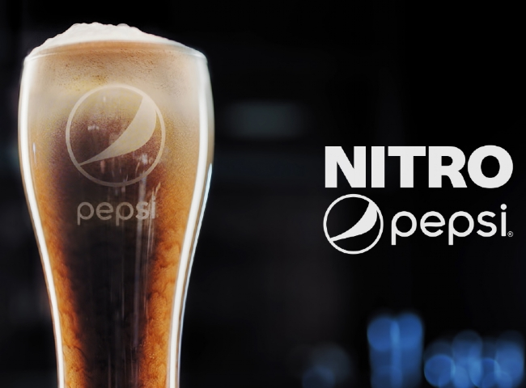

PepsiCo is launching a new nitrogen-infused soft drink called Nitro Pepsi， the company announced Thursday.

The company said Nitro Pepsi is creamier and smoother than regular Pepsi， with "velvety cascading foam." It will come in two flavors: signature cola and vanilla.

According to Pepsi， the new drink is the first-ever nitrogen-infused cola drink.

Nitrogen-filled drinks are growing in popularity among craft beer and coffee drinkers， but the trend has yet to make its way into the soda market.

"We are very excited about the progress we have made in the development of 'Nitro Pepsi，'" said Todd Kaplan， vice president of marketing for PepsiCo." With the creation of the world's first nitro Coke， we will be able to introduce a more subtle， smooth product that will reintroduce Coke to a whole new set of consumers in a way that only Pepsi can."

The company did not reveal any further details about when Nitro Pepsi will be officially launched. The company said it would have more details in the near future.