**How are industrial gases being used for manufacturing innovation?**

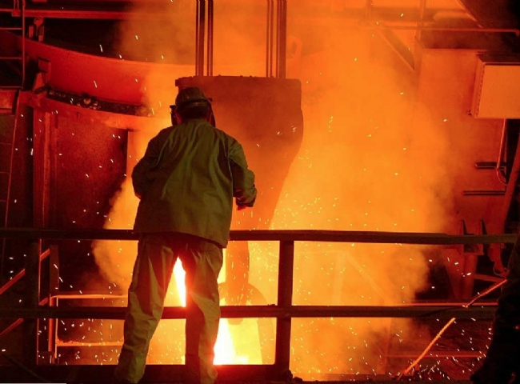

Industrial gases are gaseous materials manufactured for industrial use. The main gases supplied are nitrogen， oxygen， carbon dioxide， argon， hydrogen， helium and acetylene， although many other gases and mixtures can also be found in gas cylinders.

They are an important part of the manufacturing process in numerous industries， including

Automotive industry

Food processing

Manufacturing

Semiconductors

Steel manufacturing and metalworking

Automotive industry

The use of industrial specialty gases in the automotive industry has increased rapidly in recent decades. Automotive headlights contain xenon gas; indicator lights contain argon and nitrogen. Metal panels for doors and bodies are laser cut using special gas mixtures.

Automotive air conditioning heat exchangers are usually assembled using a brazing process in a controlled nitrogen or hydrogen atmosphere. This reducing atmosphere allows brazed joints to achieve the highest level of leak-free strength.

Airbags are a key part of today's automotive active safety systems. High pressure argon combined with other rare gases provides the right performance for ultra-high speed airbag inflation.

Food processing

The global industrial gases market is benefiting from the rising consumer demand for food freshness. Health-conscious consumers are demanding fewer additives and safer， fresher foods， which is increasing the demand for industrial gases that can replace chemical ingredients.

Gaseous packaging of food products， or MAP， is a natural method of shelf life enhancement that is growing rapidly internationally. It is often complementary to other technologies such as high-pressure and microwave methods or oxygen absorption. The correct gas mixture in MAP maintains high quality by preserving the original flavor， texture and appearance of the food.

The specific food and its characteristics must be fully considered when selecting a gas environment. For low-fat products with high moisture content， in particular， carbon dioxide must be used to inhibit the growth of microorganisms. On the other hand， if the product has a high fat content and low water activity， oxidation protection is paramount and inert nitrogen would be preferred.

Production

Industrial specialty gases are important components of the lighting industry， used to make light bulbs containing argon， nitrogen， neon， krypton and xenon.

They also fill the gaps between double-glazed windows to ensure that our modern buildings are well insulated and thus energy efficient. They are the basis for many manufacturing processes， such as the heat treatment of metals using a mixture of hydrogen and nitrogen to obtain hardness and other physical properties.

Quality control of metals， plastics and other purchased raw materials can also be performed using various HiQ high-purity gases， for example in ICP analysis. Safety testing of manufactured products and toys， including flammability or combustibility testing， can also be performed using a range of HiQ high-purity gases and gas mixtures.

Semiconductors

Semiconductors are manufactured and shaped primarily using gaseous materials. In fact， gases have always been a key factor in the manufacture of semiconductors， although the types used have changed and increased as manufacturing processes have evolved.

Gases have the ability to create chemical reactions at the molecular level that help shape the conductivity of semiconductors to allow or prevent the movement of electrons. However， to ensure that a semiconductor is configured to properly regulate electron movement， these gases must be precisely dispensed at each stage of their engineering process to stimulate the correct reaction.

Steel manufacturing and metal fabrication

Industrial gases play a key role in the production of primary and fabricated metals， including steel manufacturing and metal fabrication. Steel is essential to almost all industrial sectors， including automotive， construction and defense.

Oxygen has a very important role in the manufacture of steel: it is the main raw material used to make steel. In fact， oxygen is essential in two major steelmaking technologies: the basic oxygen process and the electric arc furnace.

In addition， argon is used together with oxygen in a common technique for refining stainless steel. Industrial gases also have important applications in metal fabrication. For example， acetylene is used for welding and metal cutting， and argon is used as a shielding gas for arc welding of non-ferrous and specialty metals. Nitrogen is used for heat treatment and metal processing of products such as sheet metal， bars， wire and castings.