**Medical Oxygen**

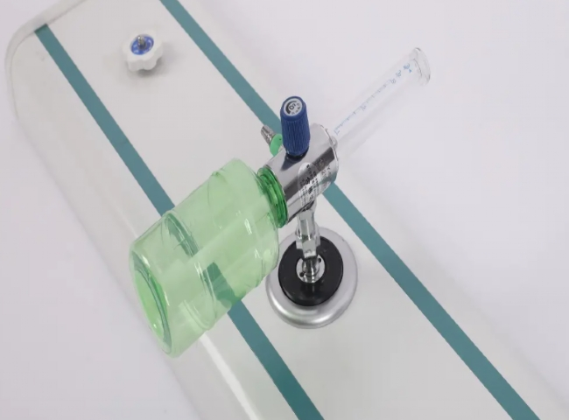

Oxygen

Oxygen is widely used in emergency medicine， both in hospitals and by emergency medical services or those providing advanced emergency care. In the prehospital setting， high-flow oxygen is indicated for resuscitation， major trauma， anaphylaxis， hemorrhage， shock， active convulsions， and hypothermia. Supplemental or additional oxygen is one of the most widely used treatments for patients admitted to the hospital. Given its growing demand， we conducted an observational descriptive study of the medical gas supply system in a rural tertiary care hospital with the objective of studying the oxygen utilization patterns and costing in the intensive care unit and operating room to improve the efficiency of the hospital's medical gas supply system. The hospital under study was a large tertiary hospital.

Medical Oxygen in Healthcare

Treatment of respiratory distress

Provide life support for patients on artificial respiration

Helps stabilize the heartbeat of acutely ill patients

As the basis for almost all modern anesthesia techniques

Restores tissues by improving oxygen supply to oxygen-stressed tissues Poisoning， cardiac or respiratory arrest， shock and severe trauma are some of the problems in restoring tissues through oxygen therapy.

Advantages of nitrogen generators

Oxygen is available at any time and any place

Cost-effective with low operating costs

Sophisticated and reliable technology

Accurate purity for every application

No purchasing commitments like bottle/bundle and tank systems

No CO2 pollution to the environment

No hazardous materials

No risk of explosion

In-house placement and production

XITE， medical oxygen generators are providing life-saving oxygen gas to hospitals around the world. Our generators produce oxygen with a purity of 93% or more， suitable for the needs of every medical facility. Whether you are in a small clinic in a rural area or a hospital in a large metropolitan area， Schitt PSA oxygen generators provide a safe， efficient and cost effective solution to the high cost of cylinder gas delivery. Our PSA technology generators have been tested and are recognized worldwide as a reliable source of oxygen.