**Global Development Overview of the Industrial Gases Industry**

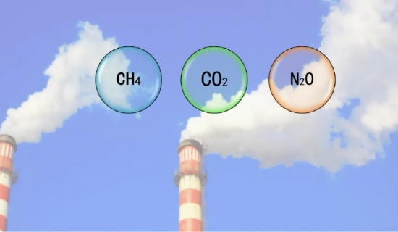

The global industrial gases market has shown steady growth in recent years， with a global industrial gases market size of US$69.8 billion in 2012 and a conservative estimate that the industrial gases industry output value will grow at a CAGR of 7.9% from 2011 to 2015.

The Global Economic Outlook report released by the World Bank indicates that the global economic growth rate will rise to 3.3% in 2014 and then gradually stabilize， reaching 3.4% and 3.5% in 2015 and 2016， respectively1

According to statistics， the growth rate of industrial gas industry is 2.0 to 2.5 times of the global GDP growth rate.2 According to this data， the global industrial gas growth rate from 2015 to 2018 can be calculated at a conservative 7% growth rate， and the global industrial gas market size can reach USD 122 billion by 2018， with a steadily expanding market size. Accordingly， as the leading product of industrial gases， the global market size of air separation gas will also expand.

According to statistics: In 2013， the top four producers in the global industrial gas market， Air Liquide， Linde， Plexiglas and Air Chemical Products， occupied a total of 75% of the market share， and the market is highly concentrated.

Due to the early start and long history of development of the industrial gas industry in western developed countries， the market is now very highly market-oriented. Many downstream users outsource their gas supply business to professional suppliers based on considerations such as reducing financial costs and improving production efficiency. According to a research report by UBS Securities， the outsourcing ratio in the overseas industrial gas market exceeded 80% in 2012.