**Demand for Medical Oxygen Concentrators in Bangladesh**

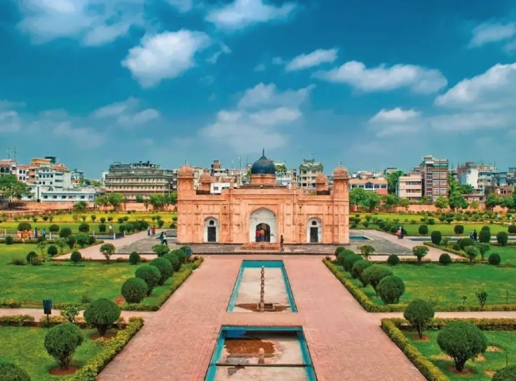

Medical oxygen is a primary gas used to treat people facing respiratory problems， whether at home or in the hospital. Since the outbreak of the infamous virus COVID-19， one in five people with coronavirus need medical oxygen to ensure their bodies have adequate levels of oxygen in their blood.

Many countries， including Bangladesh， are facing oxygen shortages. China has sent many medical oxygen machines to Bangladesh to support the country's fight against COVID-19.

How is oxygen produced?

There are two ways to produce oxygen.

Medical oxygen can be produced by separating the oxygen from other gases and purity present in the ambient air. In order to filter out the oxygen， steps such as compression， filtration and purification are performed and repeated over and over again.

Medical oxygen produced by this method has a purity of 99.5% and is subjected to rigorous testing time and time again.

Oxygen can be compressed into liquid form， but must be kept at temperatures below -182°C. This is considered one of the best ways to meet changes in demand， as one liter of liquid oxygen is equivalent to about 800 liters of gaseous oxygen.

Compressed oxygen can be produced using machines that separate nitrogen from the atmosphere and raise the oxygen level to about 93%. These machines can be either portable or larger and can be installed in hospitals. On-site gas generators are the best and most reliable source to meet the high demand for oxygen in hospitals.