**Complete Beginner’s Guide to Buying an Oxygen Concentrator**

Oxygen equipment manufacturers offer two forms， namely gas and liquid in their purest form. China Suzhou XITE meets this expectation of our customers to get the best quality products.

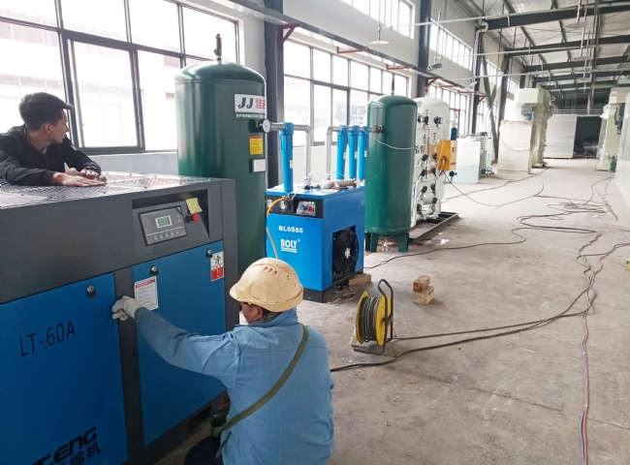

Thus， we are the best oxygen equipment supplier in China to give you quality products.

The oxygen plants established in China are recognized for their performance and advanced technology. We do have our own skilled production unit with great engineers to design， manufacture and supply the plants to our customers.

Every process is supported by experts and engineers. We are the best oxygen generator (PSA oxygen machine， oxygen equipment) supplier in the industry and you can easily get in touch with us and order online. Please find more information on our website.

Here are a few of the best features of Oxygen Plant

Leak-proof stainless steel column

High purity and stable oxygen.

Low working pressure of the oxygen plant

Very low maintenance costs for the production of oxygen gas

Raw material - free atmospheric air for oxygen/nitrogen/liquid production

Built-in liquid oxygen/nitrogen pump with internal gas vaporizer for filling cylinders with dry and high purity oxygen

Hydraulic type expander for oxygen plant

Highly efficient heat exchanger.

Oxygen plant with full service according to standard scope of delivery.