Nitrogen generator for oil and gas industry with 99.5% purity， 5KG/CM2 working pressure and 5Nm3 per hour.

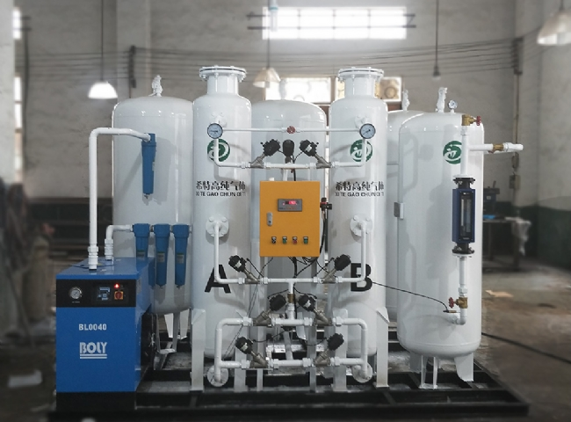
Suzhou XITE has installed a 5 cfm nitrogen generator for the oil and gas industry with 99.5% purity and 5 KG/CM2 operating pressure.

Suzhou XITE is a manufacturer of nitrogen generators， typically used in the oil and gas industry for applications including well stimulation， injection and pressure testing. Nitrogen can also be used to flood marginal fields in some enhanced oil recovery projects， more commonly using water flooding or chemical/surfactant flooding. The purity requirements of the nitrogen used depend on the requirements of the field and， most importantly， eliminate the risk of explosion and fire. In oil industry production， nitrogen is typically used at high volumes and pressures with a purity of at least 95% for pipeline filling to keep the pipeline open and for well injection to push product to the wellhead for extraction. Low-pressure applications include pipeline cleaning to maintain an inert atmosphere during maintenance， cleaning of control devices， inerting of flare gases， and most commonly， covering of gases or storage tanks.
Suzhou XITE sells a range of products for the oil and gas industry
MODEL | CAPACITY NM3/HR
XTFD-5 | 5 NM3/HR

