**Centrifugal compressor energy-saving technology application analysis**

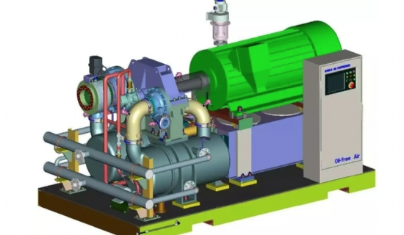

1 Existing problems

I fertilizer plant air separation workshop DA120-121 centrifugal compressor unit is one of the key equipment for fertilizer production. The unit was installed and put into operation from 1981 to June 30， 2005， according to the operation of the unit over the years， there are the following major problems.

(1) low power output， high power consumption

The single design capacity of DA120-121 centrifugal compressor is 7200m3/h. Before the renovation， two DA120-121 units run in parallel to deliver compressed air to the purification workshop， which is far below the design value， and the delivery volume is even lower in summer due to high ambient temperature. Due to the small amount of air delivered， it made it impossible for other processes in the fertilizer plant to run at full capacity to match. It can be seen that the low output of the old unit has become the most important constraint to improve urea production.

The parallel operation mode of two machines is even less efficient and less stable. When two compressors are working in parallel， the total flow rate increases， but the flow rate of each compressor itself， is reduced compared to when they are running separately. Therefore， the total flow rate after parallel operation is smaller than the sum of the respective flow rates of each machine working independently in the same pipe network system; in addition， the increase in flow rate after parallel operation makes the resistance loss of the pipe network increase， the slope of the pipe network performance curve increases， and the possibility of the working point falling into the wheezing zone increases， thus increasing the safety risks of the unit. Since the fertilizer system "8.13" transformation， the use of two units in parallel operation mode， making its low operating efficiency and high energy consumption of the unit more obvious， which has become the "bottleneck" of the fertilizer system to reduce energy consumption. According to statistics， the direct electricity consumption increases by more than 1000kW-h per hour due to the operation of two units， so the parallel operation of two units is another important reason for the low output of the old unit.

(2) Short operating cycle， poor safety and stability of the unit

The operating cycle of the unit fails to meet the design requirements， and the operation is unstable in summer， resulting in several stops; after more than 20 years of operation， the unit has a high failure rate in mechanical， electrical and instrumentation， and the operational reliability is also poor， causing at least 3 times of fertilizer system reduction or stopping every year， which seriously threatens the uninterrupted and safe operation of the fertilizer system， and also causes huge economic losses to the company (according to statistics， each direct stop economic loss of not less than 200，000 yuan).

(3) High maintenance costs

According to statistics， the annual maintenance cost of one old unit is more than 200，000 yuan， and the total annual maintenance cost of two units is more than 400，000 yuan.

Both units have the problem of no spare parts for urgent replacement. Firstly， the two units need to prepare one set of high and low cylinder rotors each， which is worth about 1 million yuan; secondly， the operating life of the gears of the speed increaser of unit 2 has reached the end-of-life time， and the gears need to be ordered and replaced urgently， which is worth about 150，000 yuan， otherwise it will affect the safe operation of the unit; thirdly， the gas coolers of section 2 and 3 of unit 1 need to be replaced， which needs 100，000 yuan. The total amount is about 1.25 million RMB.

2 Analysis of energy-saving technology of the new unit

Through analysis and research， it is determined that the assembled centrifugal compressor SVK12-4H is the new unit model. The unit is designed and manufactured by Shenyang Blower (Group) Co.， Ltd. and the structural characteristics of the unit are as follows.