**Suzhou XITE- the best manufacturer of oxygen equipment**

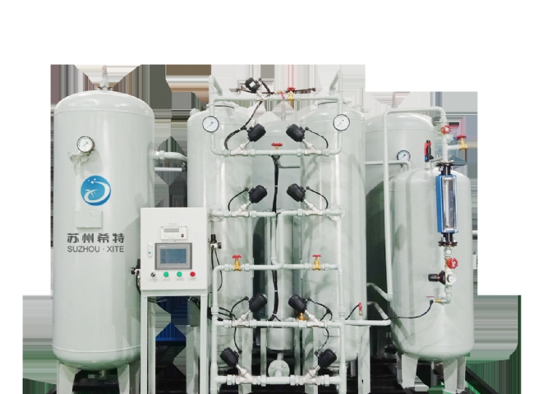

You may be aware of some of the many benefits that oxygen offers.

Used in the preparation of chemicals such as sulfuric acid and nitric acid

Useful for industrial， chemical and medical procedures

Uses related to metals: melting， welding and cutting

By understanding these important benefits of oxygen， XITE has produced the best quality oxygen equipment. After the production of these gases， they can be stored in cylinders or tanks etc. for further use when needed.

This equipment works on the principle of Pressure Swing Adsorption (PSA) mechanism， which helps to separate the nitrogen and collect the oxygen for further application.

The oxygen generated during the PSA process is distributed to the customer at the required pressure through the use of pressure reducing valves.

Try and understand Suzhou Schieter's expertise in manufacturing and supplying oxygen equipment， which will help you to make a decision.

Easy installation process

Free maintenance facilities

92 - 95% healthy oxygen production

Rotor flow (flow) meter with bypass arrangement included

Enhanced expiration points are effectively achieved with the help of a separate air dryer， without involving pressure or cleaning drops， etc.

All systems are fully automated to save time and effort

Includes both 1w+1s automation.

Additional filtration levels are available with 003ppm oil content after filtration level.

Easy oxygen production at any time according to your needs

A faulty or faulty oxygen equipment can lead to dangerous consequences for your industry and life.

And， how can you take a big risk when you choose safety and well-being for your industry?

Think twice before you choose Suzhou XITE's expertise for better reliability and long-term benefits.