**Application of hydrogen in metal injection molding/sintering process**

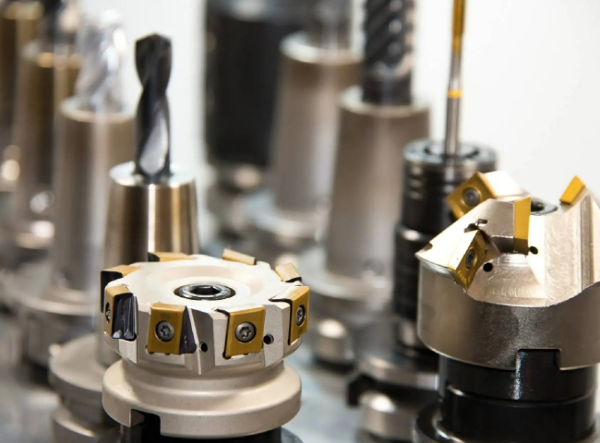

Ammonia cracking units are used to crack ammonia into nitrogen and hydrogen， and XITE is involved in the design， manufacture and export of ammonia crackers and ammonia purifiers.

Metal Injection Molding (MIM) is a metalworking process in which fine powdered metal is mixed with a binder material to form a "raw material" that is then molded and cured with injection molding. This molding process allows large quantities of complex parts to be molded in a single step. After molding， the parts are subjected to conditioning operations to remove the binder (debonding) and harden the powder. The finished product is a small part used in many industries and applications.

MIM includes different steps involving metal powders and adhesives

Mixing the two components to obtain a homogeneous raw material

Extruding the raw material to obtain spheres

Melting the pellets in an extruder

Injection of the melt into a die to obtain a green body

Drain the melt and remove the binder from the green body to obtain a brown body

Sintering the brown body to achieve a density of 95% of the current theoretical density， or even higher.

The following factors are recognized as typical process control factors for furnaces in order to achieve good reproducible quality of sintered parts

Measurement of sintering temperature

Measurement of dew point

Measurement of oxygen content with oxygen sensors

Furnace temperature profile

Cooling rate of the furnace

Furnace atmosphere capacity and composition

Position and orientation of the atmosphere layer

The sintering process is divided into three steps -

First step. Dewaxing between 300 °C - 800 °C to remove the green part of the lubricant

Second step. Sintering at 1120 to 1250 °C to form solid bridges or necks between individual powder particles

Third step. Cooling or rapid cooling to obtain microstructure and mechanical properties