**Nitrogen use in pharmaceutical production**

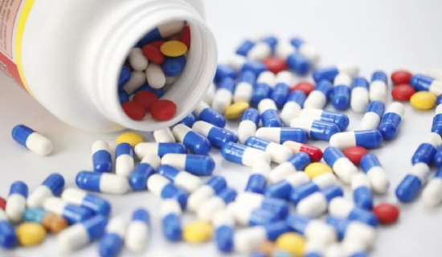

Nitrogen is often in contact with the product during the manufacturing process and is therefore relevant to the quality of the product， especially when it comes to the production of sterile products. However， the use of nitrogen is much less regulated than the use of water in pharmaceuticals. Parameters and limits must be defined by the pharmaceutical user.

As with pharmaceutical water， the primary source of information is the pharmacopoeia. The European Pharmacopoeia defines two types of nitrogen: "medical nitrogen" and "nitrogen with low oxygen content". Because， the first is used for medical purposes， for example in hospitals. The latter can be used for inerting oxygen-sensitive pharmaceuticals， for example. However， there are no parameters regarding water content， oil or particles. The only specification is a purity of 99.5% for nitrogen with low oxygen content， which seems to be insufficient. The remaining 0.5% is most likely composed of water， oil， etc.， depending on production， storage and distribution.

However， this nitrogen quality is also interesting when it comes to the use of nitrogen generators (molecular sieve technology). In many cases， these nitrogen generators can be a suitable alternative to the well known compressed gas bottles.

As in the case of compressed air (see requirements for compressed air in the pharmaceutical industry)， pharmaceutical users have to define their own specifications according to the application and product risk. 2010 ISO 8573-1 is useful here. In most cases， specifications based on Class 2 are helpful - this does not include particles larger than 5 microns. Microbial limits can be defined according to the purity class of the applied nitrogen.

In conclusion， nitrogen can be considered as an excipient， although the residual amount of nitrogen in the finished product is negligible compared to conventional excipients such as lactose. Therefore， EG guideline 2015/C 95/02 can be referred to for risk assessment or qualification requirements regarding contamination.