**The development status of air separation equipment industry in 2021， large-scale and extra large-scale become the development trend of the industry**

1、 Development of air separation equipment industry

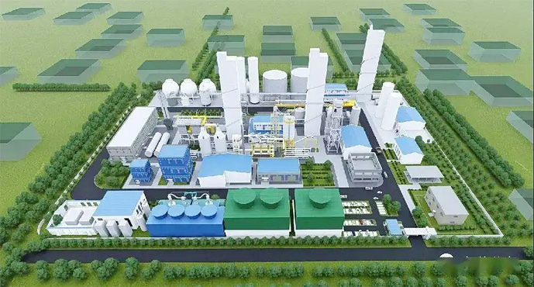

Air separation equipment refers to a device that uses air as raw material to separate oxygen， nitrogen and other gases in the air through cryogenic separation or adsorption separation. The air separation unit is mainly composed of eight systems， namely compression system， purification system， refrigeration system， heat exchange system， distillation system， product conveying system， liquid storage system and control system. The key parts of the equipment that the company can independently produce include turbine compressor， various expanders， adsorbers， plate heat exchangers， coolers， regular packing， valves， etc.

**Introduction to each system of air separation plant**

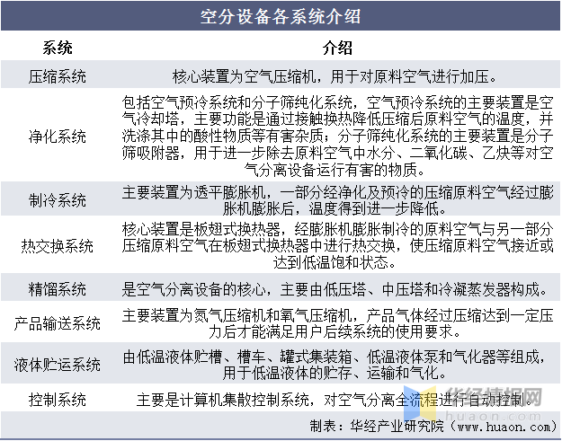

The classification methods of air separation equipment are various， which can be divided into large， medium and small according to the production capacity， and can also be classified according to the pressure required by the process， use purpose and supporting heat exchanger type.

**Common classification of air separation equipment**

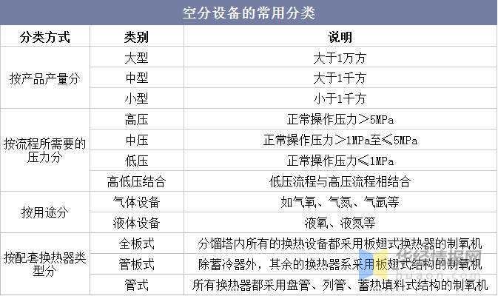

2、 Development status of air separation equipment industry

1. Output

From the supply side， the output of China's gas separation and liquefaction equipment decreased from 60900 to 46000 from 2015 to 2018， and began to grow rapidly in 2019. According to the data of China General Machinery Industry Association， the output of China's gas separation and liquefaction equipment increased to 148500 in 2021， a year-on-year increase of 17.67%.

**Output of gas separation and liquefaction equipment in China from 2015 to 2021**

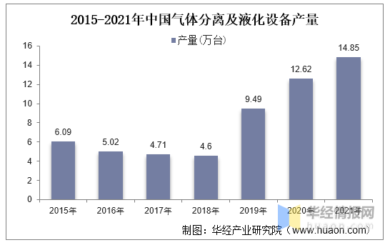

2. Market size

The domestic air separation equipment industry has experienced many years of development and is in a mature development stage. In recent years， the market scale of China's air separation equipment has grown rapidly. In 2021， the market scale of China's air separation equipment reached 27.248 billion yuan， a year-on-year increase of 24.4%.

**Market scale and growth rate of China's air separation equipment from 2015 to 2021**

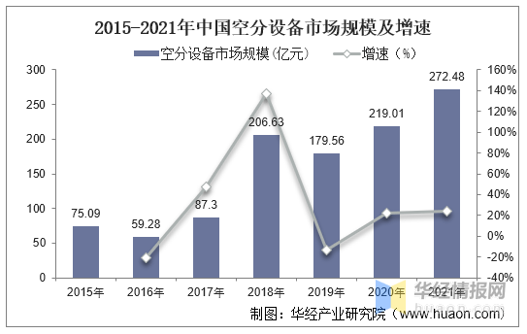

3. Sales situation

Since 2015， the sales volume of China's air separation equipment has shown an overall growth trend. In 2021， the sales volume of China's air separation equipment (equivalent to the total oxygen production capacity) reached 4.838 million m3 / h; The sales volume of air separation equipment is 350 sets.

**Changes in sales volume of air separation equipment in China from 2015 to 2021**

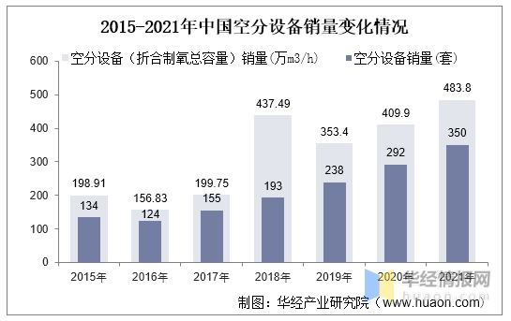

Gas separation equipment and its gas products are widely used， including energy， metallurgy， electronics， chemical industry (coal chemical industry， refining and chemical integration)， environmental protection， aerospace， scientific research， health care， food and other fields. According to the data， the sales revenue of China's air separation equipment reached 28.06 billion yuan in 2021， a year-on-year increase of 24.5%.

**Sales revenue and growth rate of China's air separation equipment from 2015 to 2021**

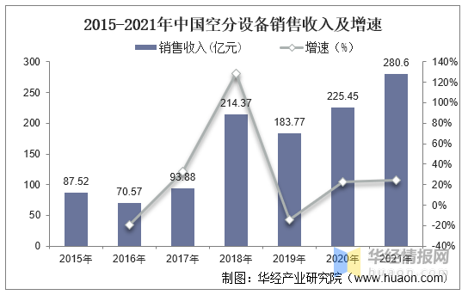

4. Average price

In terms of price， the average price of air separation equipment in China has gradually increased from 4400 yuan / (m3 / h) in 2015 to 5800 yuan / (m3 / h) in 2021.

**Trend chart of average price of China's air separation equipment from 2015 to 2021**

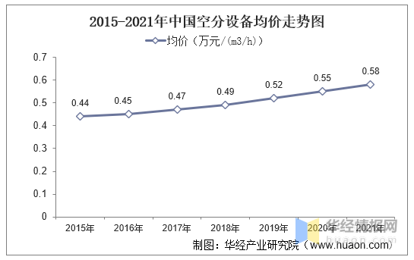

5. Import and export

In terms of import and export trade， the export volume of China's air separation equipment is greater than the import volume. In 2021， the import volume of China's air separation equipment reached 351 million yuan， a year-on-year increase of 67.14%; The export value reached 1.163 billion yuan， a year-on-year increase of 36.2%.

**Statistics of import and export volume of China's air separation equipment from 2015 to 2021**

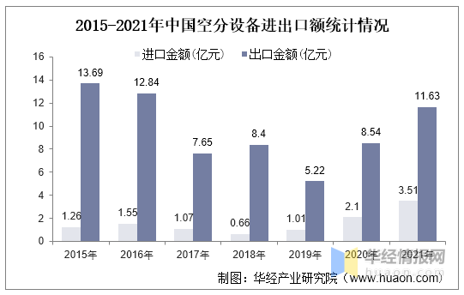

3、 Development direction of air separation equipment industry

The large-scale air separation equipment has become the development trend of the industry. First， under the background of China's "carbon neutralization" policy， carbon emissions have gradually become stricter， promoting industrial enterprises to replace old equipment with large and extra large equipment with lower energy consumption per unit. According to the calculation of China Industrial Gas Association， the unit production energy consumption of professional large-scale air separation units (oxygen production > 5000nm3 / h) is only about 1 / 2-1 / 3 of that of small-scale units (oxygen production < 1000nm3 / h). When the total oxygen production is the same， the purchase and construction of a set of large-scale air separation equipment can save equipment investment， reduce floor area， reduce product energy consumption and operation cost compared with the purchase and construction of multiple sets of small and medium-sized air separation equipment. Second， industrial enterprises "leave the city and enter the park"， the circular development of the park has entered the fast lane， and the centralized supply of the park makes the air separation equipment show a rapid large-scale trend. Third， the manufacturing technology of downstream enterprises is gradually upgraded， and the demand for oxygen is upgraded accordingly.

With the development of large-scale and extra large air separation equipment， domestic and international enterprises compete on the same platform， and high-level competition will put forward higher requirements for the company's core competitiveness. Enterprises need to strengthen technological innovation， continuously improve the technical level of super large air separation equipment， and realize synchronous development with the international advanced level; Adhere to the high-quality strategy， continuously improve the quality of products and services， and enhance brand influence and customer loyalty; Strengthen cost management， continuously improve the cost performance of products and services， and improve the comprehensive competitiveness.