**Design and piping layout of industrial compressed air systems**

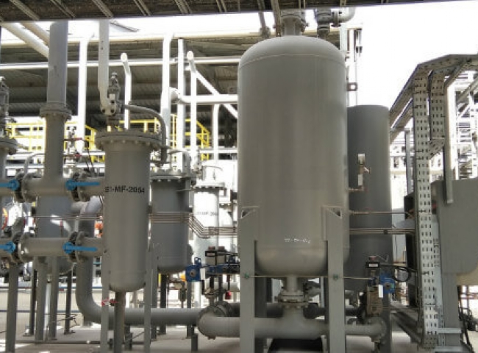

Industrial applications of compressed air range from food processing to beverage production to operations for natural gas recovery and transportation. Considering that compressed air is integral to the success of various production processes， it is vital that it meets the required usage specifications.

The key to achieving a high quality compressed air supply is to create and implement an optimized compressed air system plan. This article will consider all aspects of design and piping layout to properly produce and transport compressed air that is free of impurities.

How to Layout a Compressed Air Piping System

The effectiveness of an air compressor system is determined by the way its components are installed. To achieve optimum efficiency， system operators need to consider the various installation variables and avoid common mistakes that impede satisfactory process performance.

Key Factors in Industrial Compressed Air System Design

Piping design for compressed air systems requires engineers to consider the following four important factors.

Elevated water vapor/wet gas levels

Sharp piping angles

Obstacles that impede compressed air flow

Choice of piping materials

Ignoring these factors will result in a significant reduction in the efficiency of the finished air system.

Water vapor/moisture

In the process of compressing air， the generation of water vapor is an unavoidable by-product. Water vapor comes from the moisture in the ambient air used as a feedstock for compressed air production.

Excess moisture can damage certain types of piping because it accelerates the onset of corrosion. In addition， rusted pipes can form oxides that can be dislodged from the pipe walls into the circulating compressed air， leading to blockages. Overall， the efficiency of the system is reduced.

Effective measures to eliminate moisture from compressed air piping include the use of drying towers， air cooling units and moisture filters. These methods will pull water vapor out of the compressed air system and protect its components from damage.

Take a look at the desiccant air dryer rental from Suzhou XITE Gas today to help you meet your compressed air drying needs!

Sharp pipe angles

The presence of sharp bends in the piping of a compressed air system can slow down the flow rate and thus reduce the pressure of the supply air. Air flowing through these sharp bends can become turbulent， which reduces the flow rate of the fluid and therefore requires the compressor to work twice as hard to compensate for the pressure being discharged from the system.

Minimizing the amount of turbulence in the air compressor piping can be accomplished by installing gentler bends in the piping. A bend between 30 and 45 degrees will allow the operator to achieve maximum efficiency.

Obstacles to compressed air flow

The lumen of compressor piping can become blocked after wall corrosion and the accumulation of other particulate impurities. Flow obstructions in the air compressor line setup can be detected by changes in pressure readings at various points in the pipeline. A high pressure reading will be obtained before the obstruction and a lower reading will be obtained downstream of the obstruction.

Overcoming obstructions requires the installation of an air filter and regular maintenance of the compressor piping.

Selection of Piping Materials

A variety of materials can be used in the construction of air compressor piping. In most cases， piping is made of metal or plastic polymers. While individual operator preferences vary， each piping material has its advantages and disadvantages in terms of performance and durability.

Plastic Piping

There are several benefits to using plastic as a piping material for air compressors compared to metal piping. Plastic piping is lighter， does not corrode when exposed to moisture， and can be removed and reinstalled using basic maintenance tools.

For optimum efficiency， compressor piping is made of special plastic polymers， most commonly polyvinyl chloride or its chlorinated variants. Other effective plastics suitable for air compressor piping setups are acrylonitrile-butadiene-styrene (ABS) and high-density forms of polyethylene.

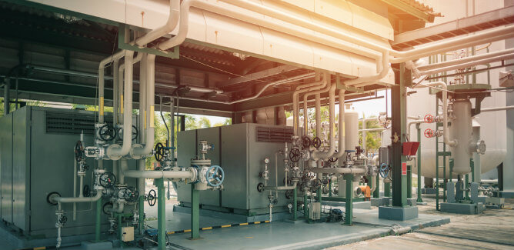

Typical Compressed Air System Layout Mistakes

When planning the design of a pneumatic piping system， engineers may overlook important details that will greatly affect the overall process efficiency. The most common forms of compressed air piping design setup errors are discussed below.

Low flow piping installation

A common air piping design mistake made by compressor piping engineers is to select flow lines that are too small to handle the amount of pressure generated during air compression. Choosing the wrong pipe size will result in rapid deterioration and increased maintenance costs.

Improperly Sized Air Compression Units

Correct sizing of the compressed air system is critical to produce maximum output. Installing an undersized compressor package will result in rapid system failure. To avoid costly process downtime， the proper compressor should be installed in the pneumatic unit.

If you need compressed air in a pinch， take a look at industrial air compressor rentals from Suzhou Schieter Gas today.

Insufficient storage

Sizing a compressed air piping system requires consideration of proper storage component sizes. Lack of adequate storage space will hinder the ability of the compressed air system to meet supply requirements.

Poor air flow routing

Instrument air piping flow design should discourage the installation of sharp turns and crossovers. The use of 30 to 45 degree turns is more appropriate for conveying compressed air than 90 degree turns， which create turbulent fluid flow and bleed off approximately 3 to 5 pounds of pressure per turn.

Trust Suzhou XITE Gases to meet your compressed air needs

With over two decades of development， Suzhou Schieter Gas has provided the most innovative solutions for the oil and gas industry. We offer industrial air compressor rentals for a wide range of industrial processes.

If you would like to learn more about our products and services， please contact us online today!