**Oxygen generator: application of oxygen field generator in various industries**

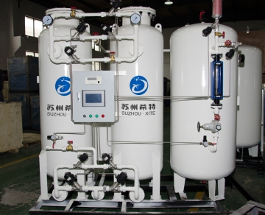

The commonly used industries of oxygen generator are as follows:

Fish farm / training ground

metallurgy

Laser cutting / cutting

Cut

Jewelry manufacturing

Hospital

Aquaculture

Laboratory

Veterinarian

Clinic medical treatment

First aid personnel

Glass manufacturing

Wastewater treatment

Chemical， ethanol production / biofuels

Reasons why companies or enterprises choose to produce their own oxygen

In the past， enterprises， hospitals and industries had no choice but to buy a large number of oxygen tanks to meet their needs; However， this method of obtaining oxygen has become a thing of the past. The oxygen generation system (oxygen generator) provided by our on-site gas system provides on-site oxygen generation system alternatives for equipment and industries requiring oxygen.