**What is a membrane air dryer?**

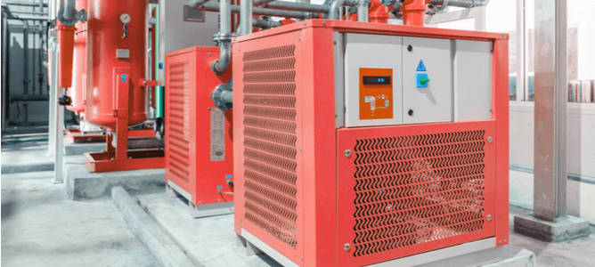

Compressed air produced for industrial use is often associated with high levels of water vapour which can damage sensitive components and alter product quality. Membrane air dryers remove excess water from compressed air， making it suitable for industrial use. This article will explain how they work and highlight the main differences with other instrument air dryer types.

Definition of a Membrane Air Dryer

What is a membrane air dryer? How do they work? What are their applications? How do they differ from other options such as desiccants? Let's start with the basics.

A membrane air dryer is a type of industrial dehydration equipment that uses a selectively permeable membrane to eliminate water suspended in compressed air. This separation membrane consists of microtubes that retain water as the air circulates through them. A stream of 'wet' compressed air passes through the membrane， resulting in water retention， while a stream of 'dry' air exits through the outlet on the other side of the membrane dryer.

Difference between membrane air dryers and desiccant dryers

A common comparison is between membrane air dryers and desiccant air dryers. Although these two low energy practical dryers achieve similar rates of compressed air dehydration， they differ significantly in their mechanisms. As mentioned earlier， membrane dryers remove water from compressed air by directing it towards a selectively permeable membrane that retains water.

In contrast， desiccant air dryers use a hygroscopic material contained within a drying tower to dehydrate the air. The usual setup is two drying towers， alternating between air drying and desiccant regeneration phases. This equipment is equipped with timers， alarms and indicators to alert the operator when to switch between the phases of the towers. While desiccant air drying can be a low energy process， the heated desiccator variant may use a significant amount of electrical energy to regenerate the desiccant material.

Membrane air dryer versus freeze dryer

Membrane dryers are a low-energy process that uses a semi-permeable membrane to physically separate water from compressed air. In contrast， a refrigerated air dryer uses the principle of water precipitation to achieve moisture removal.

A refrigerated air dryer reduces the temperature of the dry air stream to a level where the water vapour it contains condenses and falls into a container. Refrigerated dryers are available in both recirculating and non-circulating variants， the latter being the more energy efficient version.

Applications of Membrane Air Dryers

Membrane dryers are currently used in several industrial processes， including the following

Pharmaceutical manufacturing

Oil and gas exploration

Fabric/material processing

Food and beverage processing

Mould inhibition

Pharmaceutical manufacturing

The manufacture of synthetic drugs is a delicate task and requires very precise conditions to achieve an effective formulation. While compressed air is vital for some pharmaceutical manufacturing units， excess moisture can alter chemical reactions with disastrous results. A membrane air dryer will maintain a moisture-free environment for optimum productivity.

Oil and gas exploration

Oil and gas industry operators use dry compressed air to power some of their exploration work. Therefore， dedicated air drying systems are often combined with air compression units. This ensures a steady supply of dry， pressurised air for gas recovery， refining and transportation processes.

Fabric/material processing

The production of synthetic fabrics and other valuable materials on an industrial scale requires large quantities of moisture-free compressed air. Membrane dryers play an integral role in providing the high purity air required to drive these processes.

Food and Beverage Processing

Processing， packaging and preserving some commercially available food products requires large quantities of properly dried compressed air. In addition， manufacturers of both alcoholic and non-alcoholic beverages use compressed air in their processes to improve the flavour and quality of their brews. In these examples mentioned above， a membrane air dryer will eliminate the moisture that negatively affects the quality of the final product.

Mould inhibition

Industrial environments often tend to accumulate moisture， encouraging mould to grow in and around their equipment. Using a membrane air dryer， especially in conjunction with a compressed air system， will eliminate moisture and discourage the growth of mould， which can damage delicate equipment and lead to safety issues for workers and consumers.

Benefits of membrane air dryers

There are several benefits to using membrane air dryers in industrial air compressors. The most frequently cited benefits are highlighted below.

Low energy usage. Membrane air dryers do not require electricity to operate. Once set up， they require only routine maintenance， making them very cost effective.

Flexible siting. Membrane air dryers can be used in almost any industrial space and location as they do not require additional energy to operate.

High efficiency. Membrane air dryers contain a carefully designed selective membrane that removes water vapour from the compressed air stream very efficiently， resulting in high purity air.

No noise. This type of air dryer operates without noise， making it suitable for use in process equipment with strict noise level regulations. More importantly， the noiseless nature of the membrane air dryer greatly reduces the long-term risk of noise induced hearing loss.