**What is a coalescing filter and how does it work?**

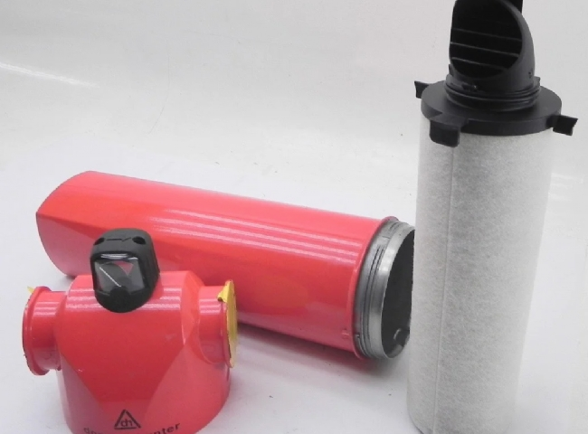

What is a coalescing filter and how does it work?

The presence of water vapor， sulfur， ethane， methane， carbon dioxide (CO2) and other impurities in industrial process fluids and products makes it necessary to use precision filtration systems to control the quality of the final product. A coalescing filter is a type of industrial equipment used for this purpose.

What is a coalescing filter

A coalescer or coalescing filter is a device that uses the principle of coalescence to separate a fluid mixture into individual pieces. Coalescing is a process by which fluid molecules coalesce (come together) to form a larger whole. Coalescing filters are capable of separating the particulate components of a mixture with efficiency comparable to that of particulate filters.

What does a coalescing filter do?

Coalescing can be used to separate components of homogeneous or heterogeneous mixtures and emulsions. There are several types of coalescing filters used in several industries， including oil and gas and chemical plants.

Common types include gas coalescers， oil coalescers， fuel coalescers and condensate coalescers for water-gas， gas-oil and fuel-gas separations.

How do coalescers work?

A coalescing filter (or coalescer for short) is a filtration system consisting of several baffle walls or screens. A stream of liquid to be separated (for example， a gas-water mixture) is applied to the filter and the baffles screen out the various components by trapping them in different zones. As a result， the component of interest can be recovered in its pure form， while contaminants are drained away for purification or treatment.

The screening mechanism works according to the physical properties of the constituent substances， such as molecular weight and density. In water-oil separation， a baffle wall in a coalescing filter directs the heavier oil molecules to a discharge point， while the water vapor molecules diffuse through the filter elements to coalesce and are discharged from the system by gravity.

Similarly， in gas-water separation， the "wet gas" (the gas stream containing water droplets) is fed into the coalescer inlet， diffused through the filter element， and discharged through the outlet port as a dehydrated gas. The denser water molecules coalesce and fall to the bottom of the tank for discharge.

Electrostatic and mechanical coalescers

Depending on the mode of operation， there are two main types of coalescing systems.

Electrostatic coalescers

Use AC or DC current， or both， to induce coalescence of droplets in a liquid mixture. Electrostatic coalescers work by transferring an electrical charge through the fluid， destabilizing the emulsion and increasing the size of the molecules， causing them to fall into a collection tank for discharge.

Typically， an AC current in the range of 50-60 Hz is used for this purpose. The resulting electric field causes an attractive force between fluid molecules， causing them to clump together to form heavier molecules. Electrostatic coalescers are widely used to separate water-fuel emulsions in offshore oil and gas production facilities.

Mechanical coalescers

do not utilize electrostatic forces， but instead use a series of filter elements or barriers for separation. Mechanical coalescers can be used in refineries to separate water vapor from hydrocarbon condensates by coalescing water molecules into larger particles that are then discharged from the system.

The purity of the separated end product depends on the selectivity of the filter element. Common materials used to manufacture filter elements are borosilicate microfibers and membrane technology.

Industrial Applications

Coalescers are used in a wide range of applications in the oil， gas and chemical industries.

Downstream Operations

Downstream in oil and gas， coalescers are used to refine products. In natural gas refineries， filter elements can be used to dehumidify natural gas to ensure purity of the product before it is sold.

Gas-oil coalescer systems can purify natural gas by removing several natural liquids and condensates. In addition， coalescing filters are actively used to prevent corrosion in oil and gas downstream assets such as compressors， amine/glycol absorbers， turbines and membrane filtration systems with efficiencies up to 99.98% by removing contaminants such as water vapor and sulfur.

Coalescing filters are used to recover lubricant when installed at the outlet of a compressor. Fluids fed to the compressor inlet may include aerosols， particulate matter， dissolved hydrocarbon fluids and slugs， and are extracted by filter elements located upstream of the compressor.

Petrochemical Industry

Liquid-liquid coalescers can be used to phase separate water vapor， amine solutions and sulfur from petrochemical feedstocks prior to storage. Removal of contaminants ensures product purity and prevents corrosion of industrial equipment.

Advantages of using agglomerators

Microfiltration using coalescers ensures a product purity of 95%. It also consumes less energy than other industrial filtration methods and is eco-friendly.