**Uses of liquid nitrogen and safety tips when handling liquid nitrogen**

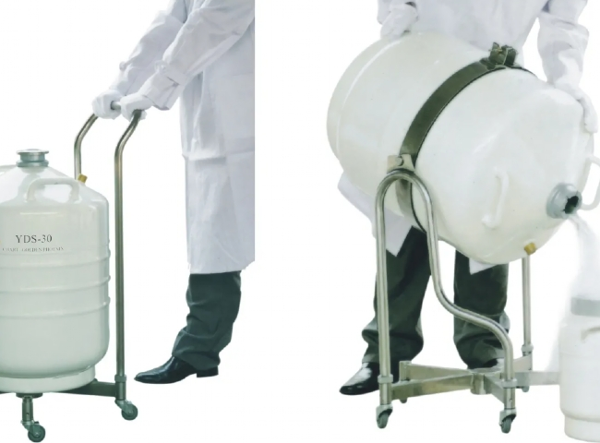

As a form of elemental nitrogen， liquid nitrogen is very cold， is used for a variety of applications and needs to be handled with care. Here we list the applications of liquid nitrogen and safety tips that users should keep in mind when handling liquid nitrogen.

What are the applications for liquid nitrogen?

Based on its low reactivity and extremely low temperature， liquid nitrogen is used in many applications.

1. in vitro fertilization It is used to cryopreserve biological samples such as eggs， sperm and embryos in order to preserve them.

2. Cryotherapy In cryotherapy， the body is exposed to extremely low temperatures for a period of time. It helps to treat skin abnormalities. This therapy is also used in athletes to reduce arthritis pain and numb any pain that occurs due to injuries.

3. machines It is used as a large coolant for vacuum pumps， superconductors and other equipment.

4. Hotels It is widely used in hotels to freeze liquids immediately or to prepare instant ice cream. Nowadays， the formation of instant ice cream that we all see in reality or online also requires liquid nitrogen， as it immediately freezes the mixture needed to make ice cream.

5. Research Because of its properties， liquid nitrogen is used in various research and development activities.

Safety of liquid nitrogen

For those who work with liquid nitrogen， it should be of utmost importance to take some precautions.

1. liquid nitrogen is very cold If it comes into contact with living tissue， it can cause severe frostbite. Therefore， users need to wear appropriate safety equipment to prevent inhalation of the extremely cold vapor. Users should also completely cover their skin when handling liquid nitrogen to avoid exposure.

2. Be aware of bursts and explosions Liquid nitrogen boils in an instant. In its change of state， it rapidly releases a large amount of pressure when it converts from liquid to gaseous state. If liquid nitrogen is enclosed in a sealed container， that container may burst or explode. The user must be careful when handling it.

3.  Large amounts of nitrogen should not be released into the air When large amounts of nitrogen are released into the air， it reduces the oxygen content of the atmosphere and increases the risk of asphyxiation. Liquid nitrogen should be used in a well-ventilated area.