**What you need to know about the maintenance of nitrogen and oxygen generators**

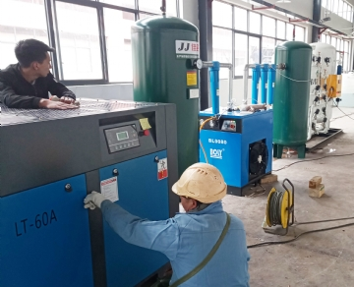

Our on-site nitrogen and oxygen generators are simple to use and do not require much maintenance. However， like most things you use regularly， annual maintenance is strongly recommended. Here is an overview of what questions you should ask yourself to see if you should maintain your oxygen or nitrogen generator and why this maintenance is so important.

Questions to ask

If you are not sure whether your nitrogen or oxygen generator needs maintenance， you only need to ask yourself these seven questions. If you answer "yes" to any of them， maintenance is strongly recommended.

Does the HMI display any maintenance information? This is a clear indicator that it is time to check your oxygen or nitrogen generator.

Has it been more than 5000 hours since the last maintenance service was performed? If so， it is best to check it again.

Can you see water or oil in the filter housing? This should not exist and should be viewed.

When your nitrogen or oxygen generator is working， do you hear any abnormal sound or notice any abnormal process? It is always better to let them check and make them anything than to ignore them and let them cause serious damage.

Is your purity level the same as when you first received an oxygen or nitrogen generator? In case of any change， please arrange maintenance as soon as possible.

Have you changed the filter recently? Depending on the frequency with which you use the generator and the type of filter your system uses， you should replace them regularly. Particulate filters usually need to be replaced every three months， coalescing filters should be replaced every six months， and carbon filters need to be replaced every year.

Does your system have a t70x-v or n-1100 sensor? If so， when was it last changed? If it has been more than one year， it should be replaced immediately.

Why maintenance is critical

Although maintaining your nitrogen or oxygen generator may seem cumbersome or unnecessary， please trust us; You'll be glad you took the time to do it. Regular maintenance will help identify small problems before they become big ones. It will extend the service life of your nitrogen or oxygen generator and ensure that your equipment operates at its best.