**What are the benefits of using on-site nitrogen or oxygen generators?**

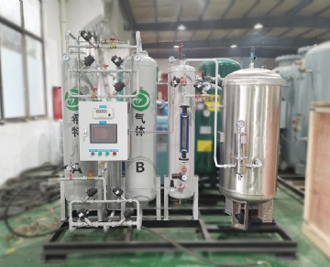

All walks of life， hospitals and enterprises may feel that they have no choice but to deliver low-temperature gases in batches to meet their needs for nitrogen and oxygen. But this is not the case. The on-site gas equipment enables these facilities to generate their own nitrogen and oxygen through the self generating system of O2 & N2 equipment. Compared with low-temperature gas， these systems have many advantages.

Advantages of O2 and N2 autogenous gas system

Low maintenance cost - the system can last for decades

Regular maintenance helps our nitrogen and oxygen generators last for decades.

Portable

Many O2 and N2 site systems provide portability. These systems can be used anywhere there is electricity and air. These systems can even be used in harsh conditions and extreme weather.

Cheaper than buying cryogenic gas

The O2 & N2 gas generation system is economical. The typical cost per CCF of a home-made gas system ranges from one-third to one-half of the cost associated with the purchase of cryogenic gas.

No longer worry about gas inventory

Since O2 and N2 equipment systems produce their own gas， any problems related to gas depletion are eliminated.

Pressure swing adsorption (PSA) and membrane technology

O2 & N2 equipment system has two ways to produce gas: membrane technology or PSA.

Adsorption process

That's adsorption， not absorption. These two words may look very similar， but they mean two very different things. The difference between adsorption and absorption is that absorption is a chemical process， while adsorption refers to the physical process of actually separating gas molecules from each other.

The PSA system is designed to produce N2 and O2. Compressed air is used to pressurize containers containing zeolite or carbon. Zeolite and carbon separate molecules according to their structure or physical composition.

Forcing air into the container will cause O2 or N2 molecules to be trapped; At the same time， another gas floats freely. As the pressure is released， O2 or N2 molecules are extracted and collected in the tank. The trapped harmful gas molecules are released into the air through the pressure relief valve. These unwanted gases are immediately recombined into ambient percentages.

Our system consists of two sieve beds working at both ends of the cycle. This ensures consistent O2 or N2 flow at all times.

N2 membrane – working principle

The membrane in our system consists of a series of hollow fibers with holes in the wall. These pores are small enough to allow O2 molecules to escape. These molecules escape when the pressure in the fiber increases.

These holes are too small to allow N2 molecules to escape. Therefore， when air is pressed down on the fiber， O2 molecules leave the fiber and N2 molecules are captured in the fiber at the other end.

The air in the membrane is usually heated. Heating the air excites molecules， which increases their chances of leaving through holes in the fiber.