**Nitrogen is added to nitro beers to make them smoother**

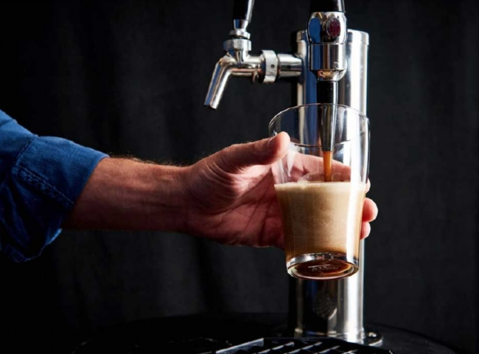

The natural carbonation that occurs during fermentation is what gives beer its character and crispness. So， as you can imagine， when someone suggested adding more gas to a beer， specifically a gas that is not carbon dioxide， the brewing community was quick to reject it.

Carbon dioxide is something that is released every time you take a sip of regular beer. It's trapped in your beer as a byproduct of yeast fermentation. The beer is either forcibly carbonated during the packaging process or conditioned in the bottle. Carbonation gives your beer a sharp texture， and we all know no one likes a bland beer.

When the brewing community was introduced to the idea of adding nitrogen to beer， it sounded like blasphemy. Nitrogen is a gas that is virtually insoluble in liquids， and to even attempt to dissolve it， it needs to be pressurized and kept very cold.

The simple act of adding nitrogen to a beer can make it smoother and profoundly change the temperature of the beer. The smoothness of these beers can be attributed to the fact that nitrogen bubbles are smaller than carbon dioxide bubbles.

The process of pouring a nitrogen-filled beer is very different from your regular beer. Each time you pour a nitrogen beer， you pour it into a glass until it is about 70-80% full， then set it aside so you can see the cascading effect. This cascading effect makes the beer look velvety smooth with all the creamy bubbles coming out of the beer for drinking. After the cascading effect is over， you put the lid on the glass and your beer will have a thick head of bubbles.

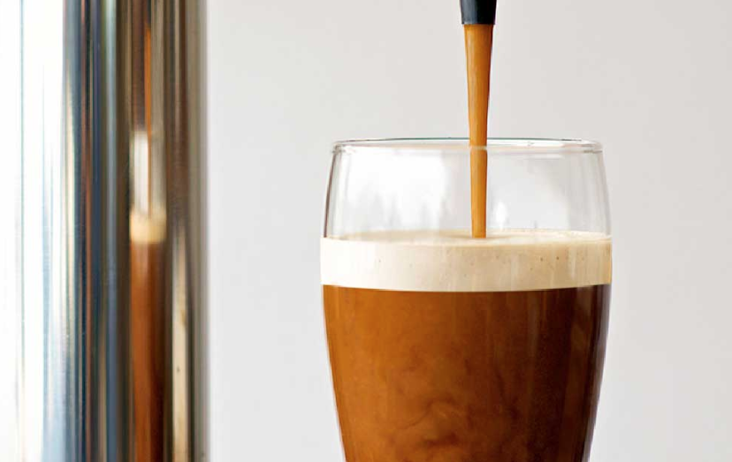

Creamy nitro beer with a layered effect

How to nitrogenate beer

The process of adding nitrogen to beer is known as nitrogenation. The way you add nitrogen to your beer can vary greatly， depending on the volume of beer you are adding nitrogen to. You can add nitrogen to your beer from a gas bottle or by using a nitrogen generator.

Smaller producers usually use pressure tanks to inject nitrogen into the beer. For stouts， a pressure of 7 psi above atmospheric pressure will leave 40 parts per million of nitrogen in solution， enough to give us a medium to large nitro taste.

Nitro beers from kegs or tanks are best served from a dedicated nitro tap. It has a restriction plate with a small hole before the tap. This helps the nitro bubbles to burst and ensures a sizable head and creamy mouthfeel.

Nitrocellulose beer in a can

Guinness， the company large in the nitro beer movement， figured out how to can them. Prior to 1980， nitro beers were only available on taps， and those taps were dedicated to pouring nitro beers only. Guinness revolutionized the industry by making plastic parts that helped inject nitrogen into cans and bottles under pressure.