**Pressure vessel welding process in accordance with ASME Pressure Vessel Code**

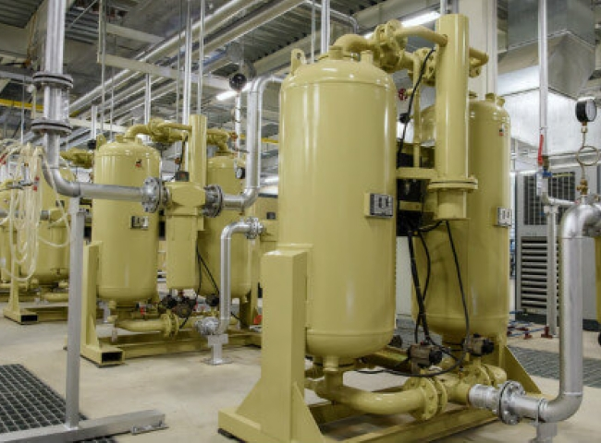

The air compressor is a practical application of Charles' Law. This process converts power (electricity to pump air) into potential energy in the form of pressurized air and finally kinetic energy to expel the gas or air. Many industries require air compressors to perform various processes in their plants.

SCFM

Standard cubic feet per minute (SCFM) is the flow rate of gas or air through a compressor at standard temperature and pressure conditions. The standard temperature range for calculating SCFM flow rates is 60°F to 68°F， with a pressure of 14.7 psi and a relative humidity of 36%. Since SCFM measures the volumetric airflow under standard conditions， it is always higher than the CFM value of an air compressor.

SCFM vs. CFM

Both SCFM and CFM are basic values indicating the airflow rate in a compressor. SCFM measures this value based on "ideal" temperature and pressure conditions， while CFM measures the "actual" air flow rate. CFM is the accepted value for measuring airflow rates in the U.S.

CFM (cubic feet per minute) is a measurement of the volume of air or gas that flows through a compressor in one minute. Sometimes the CFM rating of an air compressor provided by the manufacturer can be somewhat inaccurate. Therefore， the best way to find out the most accurate CFM value for your air compressor is to test it at your facility.

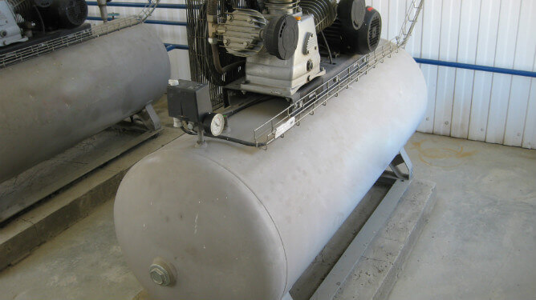

You can find the CFM value of your air compressor by following these simple steps

Find the volume of the air compressor oil tank in gallons. Most manufacturers state this on their products.

Divide this value by 7.48. This value will be the volume of your tank.

Release air from the compressor.

Refill the air compressor with air and record the time it takes to refill the tank while watching the tank gauge. Record the PSI (pounds per square inch) when the compressor starts and at startup. You can refer to the first PSI measurement as PSI 1 and PSI 2.

Subtract PSI 1 from PSI 2 and divide the difference by 14.7. This value gives you the pressure in the compressor tank (expressed as atmospheric pressure) at the time of refill.

Divide the previously obtained tank volume by the pressure in the compressor tank at the time of refill and multiply by that value.

Convert this value to minutes by dividing it by the number of seconds it takes for the compressor to pump that amount of air.

Multiply that value by 60 to get the CFM of your air compressor.

Knowledge of SCFM is quite useful when working with air compressors. Once you understand how to convert units to SCFM， you will be able to easily convert SCFM to psi and vice versa.

What are some other important air compressor ratings to consider?

After determining the SCFM or CFM value， there are some other basic ratings to consider when selecting an air compressor， such as.

PSI

PSI (pounds per square inch) indicates the amount of pressure forced through the compressor per square inch of area. Since pressure is inversely proportional to area， it increases as area decreases， and vice versa. Applications such as cutting， painting， sealing， sanding and tapping will require a high PSI. factory tools with PSI ratings of 40-90 may be sufficient to perform most of these processes.

Work Cycle

Air compressors perform rigorous work， so in order to be used efficiently， they operate on an on/off cycle， also known as the duty cycle. During their off cycle， the compressor does not necessarily shut down， but does not actively pressurize any volume of air. Duty cycle is usually specified as a percentage， i.e. if a compressor has a duty cycle of 60/40， the compressor operates 60% of the time and idles the remaining 40% of the time.

Horsepower (HP)

Horsepower is a measure of the motor efficiency of an air compressor at a given CFM and PSI. It describes the working capacity of the machine and is one of the easiest attributes to identify before completing your purchase. Depending on your application， for best results， you may choose an air compressor rated higher enough than your current CFM.

Gallons

Gallons refer to the storage capacity of the air compressor tank. Typically， the larger the gallon size of an air compressor， the longer the air compressor can perform. This consideration is especially important for projects that require continuous airflow.