**New features of the approaching demand for industrial gases**

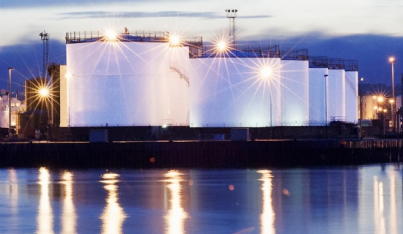

The new characteristics of demand for industrial gases are gradually approaching. In terms of the downstream application industries of industrial gases， the main industries are iron and steel， coal chemical， petrochemical and electric power. And the past 10 years have been a decade of strong global economic growth， and the scale of industries such as iron and steel， coal chemical， and petrochemical has expanded rapidly. Driven by this， the global industrial gas market will grow by about 8% in 2011， and the global industrial gas market size will be close to 52 billion USD by 2015; if measured by volume consumption， the global industrial gas market demand will grow at an average annual rate of 5% in the next five years， and the total market will reach 530 billion cubic meters by 2015.

Among them， as an emerging economy， China's steel and coal chemical industries have been developing rapidly in recent years， and their production capacity continues to expand， so the demand for industrial gases is also rapidly boosted. China's industrial gas market has been regarded as the most dynamic market in the world. from 2003 to 2005， the output value of China's gas industry grew at an average annual rate of 65%， while the global average annual growth rate was only 12%. in 2007， the total output value of industrial gases in China was 50 billion yuan， and the demand is increasing at an annual rate of 10%， and the total output value is expected to reach 100 billion yuan in 2016. This means that the market capacity of industrial gases will continue to expand and high-quality enterprises will not encounter industrial bottlenecks in the growth process. Moreover， as long as these high-quality enterprises can seize the opportunity of the booming industry， they have the chance to step into the high growth track.

Downstream demand is gradually emerging new features

More importantly， the current downstream demand has emerged two clear features. First， energy conservation and emission reduction industrial policy guidance is clearer， making the trend of eliminating backward production capacity of iron and steel， coal chemical industry， etc. is also more clear. In this context， the efficacy of a single set of equipment in these industries will become bigger and bigger in the future， which is also a new growth opportunity for industrial gases.

Second， industrial gas outsourcing business is more prominent. Large-scale air separation equipment is expensive， depending on the equipment package， the price of a 20，000-grade air separation equipment is usually between 50 million and 80 million yuan. If the gas business is outsourced， gas-using enterprises do not need to bear the large initial capital investment， but invest these resources in projects that can generate more efficient benefits and concentrate on their main business. At the same time， by outsourcing the gas business， the gas-using company does not need to undertake maintenance of air equipment， etc. Therefore， more and more gas-using companies are outsourcing their gas business， and this is becoming a trend in Europe. For example， in Europe and the United States， 95% of the industrial gas projects of steel companies are outsourced. However， in China， due to the early development process， steel companies pursue big and complete， resulting in only 40% of industrial gas outsourcing at present. However， the proportion of outsourcing is rapidly increasing in new steel projects， thus providing a new growth opportunity for industrial gas development in China.

These trends then provide new growth opportunities for air splitting equipment companies. The outsourcing share of the industrial gas market will increase from 40% in 2008 to 50% in 2015， which means that the share of specialized gas groups or companies in China's industrial gas market share will increase from $2 billion in 2008 to $4.6 billion in 2015. This means that those related stocks that successfully cut into the industrial gas business are facing a new and rapidly expanding industrial cake. In other words， stocks similar to Shaangu Power and Hangxiao share in the air separation equipment category may see major changes in the structure of their future business revenue sources. Because once they successfully cut into the downstream fields such as steel and coal chemical industry to implement outsourcing business， they will often get at least 15 years of gas supply contracts from the downstream demand side， and the industrial gas business will form a stable business source. The experience in overseas markets shows that 90% of the revenue of the top-ranked global air separation equipment companies are gas business， while only 10% are air separation equipment. Accordingly， it can be presumed that listed companies such as Hangxiao， which are actively involved in the field of industrial gases， will have relatively strong growth engines in the future. This is actually the direct driving force behind the recent repeated activity of such stocks， which is stronger than the general market.

Low absorption of strong business expansion stocks

Of course， due to the current A-share market trend is relatively sluggish， in the operation， should not chase high this sector of stocks. But because of their future industrial development space is optimistic， earnings growth is expected to determine， you can use the adjustment of the general market brought about by the share price low this opportunity， slowly low suction to build a position. Among them， Hangxiao shares， Shaangu Power， Chendian International， Kemet Gas and other stocks are especially worth tracking.