**Nitrogen applications in the oil and gas industry**

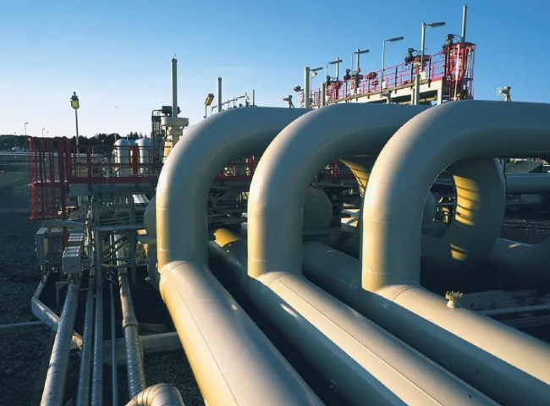

Nitrogen

Nitrogen is a gas that is found in large quantities in the air. It has many applications such as food processing， heat treatment， metal cutting， glass manufacturing， the chemical industry and many other processes that rely on nitrogen in some form or capacity.

Nitrogen is commonly used in the oil and gas industry for applications including well stimulation， injection and pressure testing. Nitrogen can also be used to flood marginal fields in some EOR (enhanced oil recovery) projects， more commonly using water flooding or chemical/surfactant flooding. In addition， nitrogen can be used to help prevent flammable gas flaring and to protect tubing from downhole corrosion.

Nitrogen， as an inert gas， provides most of the functions for oil， gas and petrochemical companies. Used primarily for equipment maintenance， start-up and shutdown preparation， nitrogen purging and subsequent nitrogen leak testing constitute the critical path to favorable results for any project. As a result， nitrogen has become extremely important for both onshore and offshore applications. Nitrogen provides a dry air supply that can extend the life of some systems and prevent failures from occurring.

In workover and completion operations， nitrogen is an excellent choice for displacing well fluids in order to initiate flow and clean the well due to its low density and high pressure properties. This high-pressure gas is also used for production stimulation through hydraulic fracturing. In addition， nitrogen is used in cementing operations and to control the weight of cement slurry.

In addition， nitrogen is used to maintain pressure in reservoirs that have been depleted of hydrocarbons or have undergone natural depressurization. Because nitrogen is immiscible (or does not mix) with oil and water， nitrogen injection programs or nitrogen flooding can be used to transfer leaking pockets of oil and gas from injection to production wells.

Nitrogen can also be used for filling and cleaning of pipelines. For example， nitrogen can be used as a driving force to push pigs through a pipeline. Nitrogen can also be used to clean the pipeline after filling is complete. In this case， the dry gas is passed through the pipe without the pigs to dry any remaining moisture in the pipe.

In addition， nitrogen can be used in FPSOs and other applications where hydrocarbons are stored. In a process known as "tank covering"， nitrogen is applied to an empty storage facility to improve safety and provide a buffer for incoming hydrocarbons. Other applications for nitrogen in the oil and gas industry.

Nitrogen Filling

Nitrogen filling， also known as tank filling and tank lining， is a process in which nitrogen is applied to a storage vessel consisting of chemicals and hydrocarbons that are volatile and react with oxygen. When a tank is purged with nitrogen， the materials inside the tank are not in contact with oxygen. Purging gives the product a longer life and reduces the potential explosion hazard.

Nitrogen purging

To replace any undesirable or hazardous atmosphere with an inert， dry atmosphere， nitrogen purging is used， i.e.， to limit the oxygen content so that it does not react with other explosive mixtures and hydrocarbons. Displacement and dilution are the two most common purging methods. Which method is suitable for which system depends on its geometry. The displacement method is more effective for simple systems and the dilution method is used for complex systems.

Cooling the refinery catalyst

When a refinery is to be shut down， it is advisable to minimize the temperature of the catalyst associated with the process as early as possible. To do this， pumping equipment can be used to deliver large amounts of nitrogen to the catalyst to cool it quickly and save downtime.