**What are the benefits of using nitrogen in the aerospace industry?**

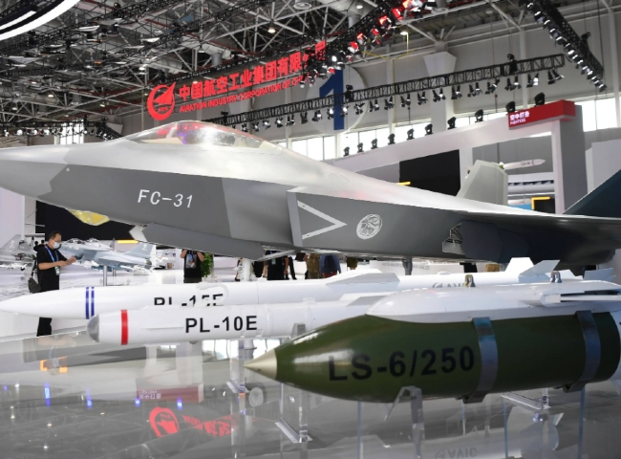

In aviation， the safety and reliability of aircraft components and systems are of paramount importance. Many aircraft components catch fire easily， especially jet fuel tanks. in 1996， an electrical spark in the fuel tank of an aircraft caused an explosion when it came into contact with air and fuel vapors. This incident resulted in the deaths of 230 passengers， including service personnel. To reduce the risk of this hazard， the Federal Aviation Administration (FAA) recommends that aircraft manufacturers use fuel inerting equipment to reduce the flammability of the gas in the fuel tank.

In method-fuel inerting， chemically inert materials are used to prevent combustion in a compact environment. The element that is widely used to maintain safety is nitrogen. This is because its inertness prevents combustion and/or explosion in sensitive processes， especially those operating at high temperatures and pressures. Another reason that makes nitrogen a specialty inert gas in demand is that it does not leak through popular materials such as rubber and seals.

The role of nitrogen in the aviation industry

Here are some examples of specialized aviation applications driven by nitrogen and nitrogen power generation

Aircraft Tire Inflation

Many regulatory agencies require the use of nitrogen when inflating aircraft wheels. It creates a stable and inert environment while also removing moisture from the cavity of the wheel. Nitrogen is helpful in preventing oxidative damage to rubber wheels. Nitrogen also helps prevent any explosions or fires， wheel corrosion and fatigue caused by heat transfer from the brakes.

Aircraft Fuel Tank Covering

Fire is a major problem in the aviation industry， especially in fuel tanks used to transport jet fuel. Manufacturers must use fuel inerting equipment to reduce the risk of flammable exposure in these aircraft fuel tanks to reduce the chance of fires. This approach includes the use of chemically inert substances， such as nitrogen， to inhibit combustion.

Fuel strut maintenance

An oil strut is a hydraulic shock absorber used in the landing gear of an aircraft. It consists of an oil-filled cylinder and a hollow， perforated piston into which oil is gently pumped when a compressive force is applied to the landing gear. Many shock absorbers incorporate compressed nitrogen， which increases the damping effectiveness of the landing gear. When a large aircraft lands， the oleo struts generate a lot of heat， which can lead to "dieselization" of the hydraulic fluid at extreme temperatures and pressures if oxygen is present. Other advantages of nitrogen include the fact that it is a pure， dry gas with no moisture to promote corrosion. Second， nitrogen is less likely to penetrate through seals than air containing 21% oxygen. As a result， nitrogen is the most effective compressed gas for oleo struts， and gas replenishment is an essential element of the maintenance program.

Escape slide inflation systems

Nitrogen is used in escape slide and life raft inflation systems because it is inert and non-explosive. the FAA requires a 90-second evacuation of the entire aircraft using half of the available evacuation exits. Inflation systems typically include a pressurized cylinder， a regulating valve， two high-pressure hoses and two aspirators. The cylinder can be between 100 and 1，000 cubic inches in size and must be filled with gaseous nitrogen or a mixture of gaseous carbon dioxide and nitrogen to a pressure of about 3，000 psi. Carbon dioxide is used to slow down the release of the gas from the valve.

The best option for producing your own nitrogen

Manufacturers and airline operators have seen professional gains in overall efficiency from using on-site nitrogen generators. The following is a list of the best options aircraft manufacturers have received for using nitrogen in the aviation industry.

1. Cost-effective

The cost of manufacturing nitrogen for these systems is low because the source material is air， ensuring a steady supply of nitrogen at the location where it is used. XITE offers many alternatives to reduce the total cost of your nitrogen production system.

2. 2. Convenient supply

With XITEc's nitrogen generators， nitrogen can be supplied on demand， 24 hours a day， avoiding the risk of running out of gas. In addition， since the gas is produced in the air， it avoids any security issues associated with transporting cylinders in and out of the airport through security checks.

3. Reliability

Aircraft NGS systems have a much longer service life due to automated operation. In addition， maintenance costs are typically cheaper than traditional methods and parts replacement is minimal.

4. Eco-Friendly

The traditional method of delivering nitrogen in industry， liquefying or compressing nitrogen into cylinders for sale， is an energy-intensive operation that has a negative impact on the environment.

By eliminating the need for large coolers and compression equipment， on-site nitrogen production solutions save energy for industrial customers. Toxic emissions are reduced through low power operation and non-hazardous storage.

If you are also facing nitrogen supply or related problems， please contact us. We will provide you with the best solution.