Nitrogen generators for electronics manufacturing

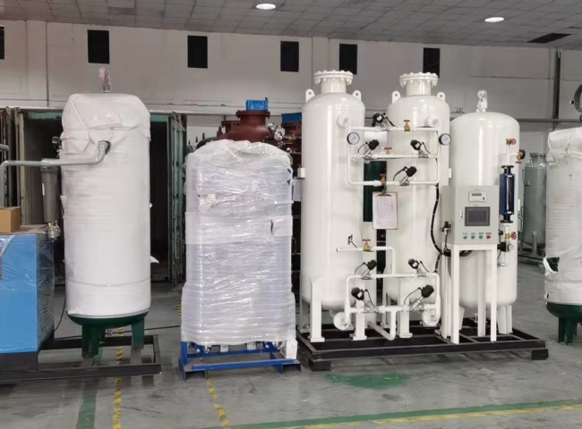
Our nitrogen generators are used in soldering processes in the electronics manufacturing industry and ensure the production of quality products in an inert atmosphere. Nitrogen helps prevent oxidation in selective soldering and convection reflow， while reflow ovens use nitrogen to provide a time and temperature controlled environment to effectively solder surface mount components.
Suzhou XITE provides critical nitrogen generators for the electronics manufacturing industry that are designed to produce the consistent purity and flow rates required for your process. Nitrogen generator systems provide nitrogen purity of 99.9-99.999% and flow rates of up to 35，000 SCFH per unit. use industrial nitrogen generators to generate nitrogen on demand in-house and eliminate the hassle of long-term gas contracts and delivery. Nitrogen production is a safer， smarter and more economical solution.
Savings of 50-90% compared to liquid bulk
Fast payback with an average ROI of 12-14 months
Eliminates deliveries and contracts
18-24 year system life， depending on system maintenance

