**Air Supercharging Systems - How do high pressure superchargers work?**

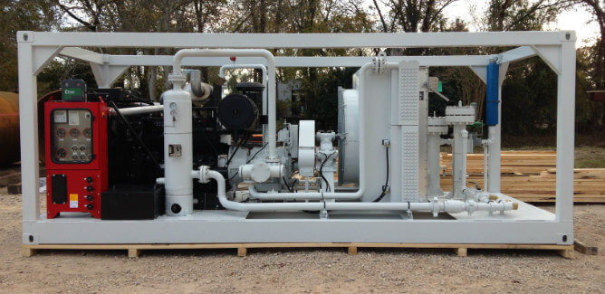

Compressed air is a basic requirement for some industrial processes， such as sandblasting， pressure testing， etc. Typically， pressurized air is supplied by standard air compressors such as rotary screw， rotary vane and reciprocating piston types. However， for high power applications， the air pressure from these systems is often insufficient to perform a specific process.

Therefore， equipment may need to increase the air pressure from the main feed. Special processes in industrial equipment require oil-free or lubricated air at very high pressures.

High pressure compressed air can be easily and efficiently generated using booster compressors. But what are they?

This article will discuss what booster compressors are， how they work， and common industrial applications.

What is a booster compressor?

A booster system is a device used to increase or amplify the pressure of air from an existing compression system by means of an additional compression stage. A booster air compressor can increase the existing air pressure from 80 - 150 psig to as high as 2000 psig.

Using a compressed air flow booster is one of the most economical ways to obtain the higher process gas pressures required by industrial equipment.

How an Air Booster Works

A booster air compressor or compressed air pressure amplifier works on the simple principle that pressure increases as volume decreases within a closed system (not a vacuum). An air booster compression system consists of a receiving tank， piping and discharge tank.

The receiver tank has an inlet that receives compressed process air from the primary feed and increases the pressure further through several compression stages. In addition， the receiving tank acts as a limited storage capacity when the system is not actively delivering compressed air.

After a series of compression stages， the pressurized air flows through a duct into a discharge tank， which contains an outlet to supply the gas to the site.

Applications of air intensifiers

Air intensifiers are used in a number of industrial applications， including the following.

PET bottle manufacturing

Automated polyethylene terephthalate (PET) manufacturing requires a constant supply of high-pressure gas that is not available from standard compression systems. Pressurized air compressors help deliver high-pressure air to the blow molding machines that produce PET bottles. Blow molding technology uses compressed air to force the molten thermoplastic into the mold.

Industrial Pressure Testing

Pressure testing of pipes， tubes， vessels， ductwork， etc. helps to determine their integrity， reliability and sealing before and after field commissioning. It is typically performed during maintenance operations to ensure that essential equipment is functioning and in good condition.

Compressed air or nitrogen leak testing procedures (also known as pneumatic testing) involve passing compressed air through a vessel to the desired pressure range and subsequently "bleeding" the gas through a pressure relief valve located on the system under test. Pneumatic booster pumps or pneumatic intensifiers are suitable for this purpose.



Oil and Gas Production and Transportation

Pressurized fluids， such as carbon dioxide (CO2) and nitrogen， are useful for specific processes in hydrocarbon production. In the secondary and enhanced oil recovery (EOR) phases of crude oil production， pressurized gas can be used to increase the pressure within the formation to stimulate the well and increase declining production.

Some examples are gas lift and nitrogen injection techniques. In addition， high-pressure air or nitrogen can be used to remove impurities and toxic materials from hydrocarbon pipelines. This nitrogen purge for pipeline drying can be helpful during pipeline decommissioning or commissioning.

Booster systems can amplify the gas pressure from on-site nitrogen generators (PSA nitrogen generators， nitrogen plants) or air compressors to enable these processes. For short-term applications， check out Suzhou Schieter Gas' selection of nitrogen generators (PSA nitrogen generators， nitrogen equipment) for rent and industrial air compressors for rent.

Booster vs. compressor. Which do you need?

Both air booster systems and air compressors provide pressurized air. However， a compressor with a booster system attached can achieve air pressures up to ten times higher than a standard system. If your process requires a high range of pressures， then you will need an air pressure multiplier.